### Лабораторная работа № 1_1 Шаблон Northwind (Oracle – Neo4j)

### модель реляционная < --- > модель графовая

### Введение в Neo4j

**Sample Scripts**

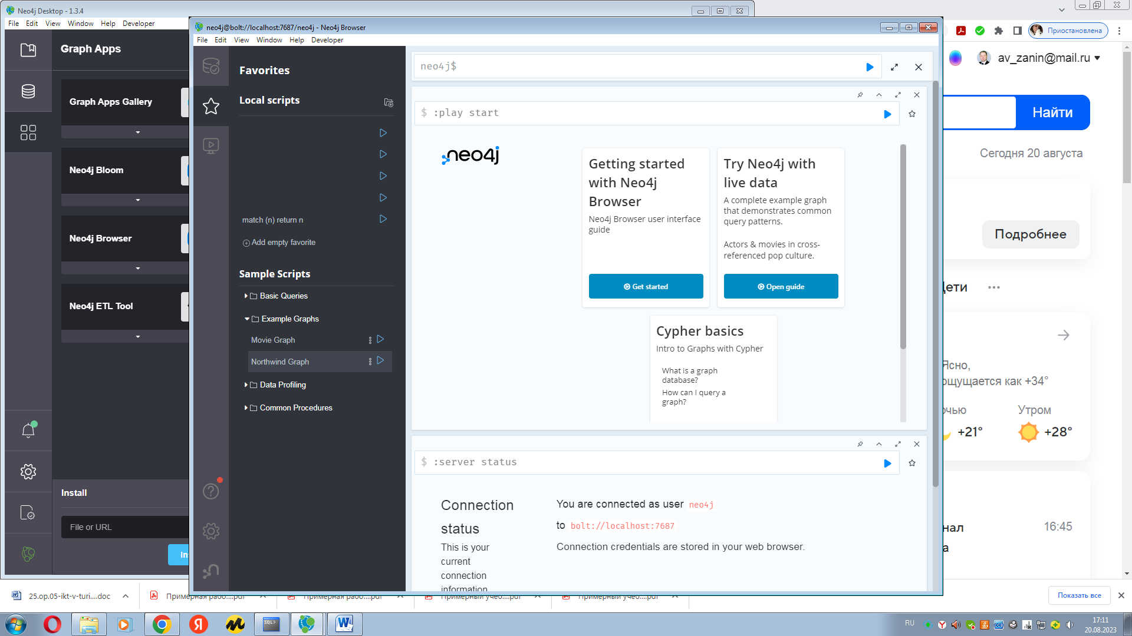

**About the Northwind sample database**

The Northwind database is a sample database that was originally created by Microsoft and used as the basis for their tutorials in a variety of database products for decades. The Northwind database contains the sales data for a fictitious company called “Northwind Traders,” which imports and exports specialty foods from around the world. The Northwind database is an excellent tutorial schema for a small-business ERP, with customers, orders, inventory, purchasing, suppliers, shipping, employees, and single-entry accounting. The Northwind database has since been ported to a variety of non-Microsoft databases, including PostgreSQL.

The Northwind dataset includes sample data for the following.

* **Suppliers**: Suppliers and vendors of Northwind
* **Customers**: Customers who buy products from Northwind
* **Employees**: Employee details of Northwind traders
* **Products**: Product information
* **Shippers**: The details of the shippers who ship the products from the traders to the end-customers
* **Orders and Order_Details**: Sales Order transactions taking place between the customers & the company

The Northwind sample database includes 14 tables and the table relationships are showcased in the following entity relationship diagram.

О базе данных образцов Northwind База данных Northwind - это образец базы данных, которая изначально была создана корпорацией Microsoft и десятилетиями использовалась в качестве основы для их руководств по различным продуктам баз данных. База данных Northwind содержит данные о продажах фиктивной компании под названием “Northwind Traders”, которая импортирует и экспортирует фирменные продукты питания со всего мира. База данных Northwind - это отличная учебная схема для ERP-системы малого бизнеса с клиентами, заказами, запасами, закупками, поставщиками, доставкой, сотрудниками и бухгалтерией с единой записью. С тех пор база данных Northwind была портирована на множество баз данных, не относящихся к Microsoft, включая PostgreSQL. Набор данных Northwind включает в себя выборочные данные для следующего. • Поставщики: Поставщики и продавщицы Northwind • Клиенты: Клиенты, которые покупают товары у Northwind • Сотрудники: Сведения о сотрудниках Northwind traders • Продукты: Информация о продукте • Грузоотправители: Сведения об отправителях, которые отправляют продукцию от торговцев,

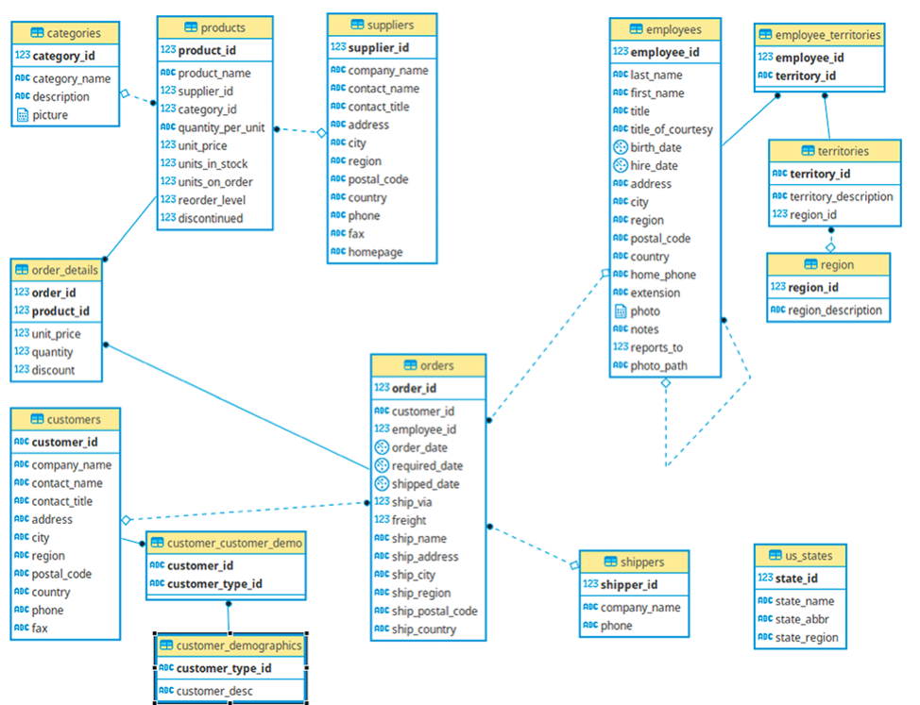

COMMIT;

DROP TABLE Customer_customer_demo CASCADE CONSTRAINTS;

DROP TABLE Customer_demographics CASCADE CONSTRAINTS;

DROP TABLE Employee_territories CASCADE CONSTRAINTS;

DROP TABLE Orderdetails CASCADE CONSTRAINTS;

DROP TABLE Orders CASCADE CONSTRAINTS;

DROP TABLE Customers CASCADE CONSTRAINTS;

DROP TABLE Products CASCADE CONSTRAINTS;

DROP TABLE Shippers CASCADE CONSTRAINTS;

DROP TABLE Suppliers CASCADE CONSTRAINTS;

DROP TABLE Territories CASCADE CONSTRAINTS;

DROP TABLE Us_states CASCADE CONSTRAINTS;

DROP TABLE Categories CASCADE CONSTRAINTS;

DROP TABLE Region CASCADE CONSTRAINTS;

DROP TABLE Employees CASCADE CONSTRAINTS;

COMMIT;

Продукты: Информация о продукте

**CREATE** **TABLE** Categories

(CategoryID NUMBER(5) NOT NULL PRIMARY KEY,

CategoryName VARCHAR(25),

Description VARCHAR(255));

**CREATE** **TABLE** Customers

(

CustomerID NUMBER(5) **PRIMARY** **KEY** NOT NULL,

CustomerName VARCHAR(50),

ContactName VARCHAR(50),

Address VARCHAR(50),

City VARCHAR(20),

PostalCode VARCHAR(10),

Country VARCHAR(15)

);

**CREATE** **TABLE** Employees

(

EmployeeID NUMBER(5)**PRIMARY** **KEY** NOT NULL,

LastName VARCHAR(15),

FirstName VARCHAR(15),

BirthDate DATE,

Photo VARCHAR(25),

Notes VARCHAR(1024)

);

**CREATE** **TABLE** Shippers(

ShipperID NUMBER(5) **PRIMARY** **KEY** NOT NULL,

ShipperName VARCHAR(25),

Phone VARCHAR(15)

);

**CREATE** **TABLE** Suppliers(

SupplierID NUMBER(5) **PRIMARY** **KEY** NOT NULL,

SupplierName VARCHAR(50),

ContactName VARCHAR(50),

Address VARCHAR(50),

City VARCHAR(20),

PostalCode VARCHAR(10),

Country VARCHAR(15),

Phone VARCHAR(15)

);

**CREATE** **TABLE** Products(

ProductID NUMBER(5) **PRIMARY** **KEY** NOT NULL,

ProductName VARCHAR(50),

SupplierID NUMBER(5),

CategoryID NUMBER(5),

Unit VARCHAR(25),

Price NUMERIC,

**FOREIGN** **KEY** (CategoryID) **REFERENCES** Categories (CategoryID),

**FOREIGN** **KEY** (SupplierID) **REFERENCES** Suppliers (SupplierID)

);

**CREATE** **TABLE** Orders(

OrderID NUMBER(5) **PRIMARY** **KEY** NOT NULL,

CustomerID NUMBER(5),

EmployeeID NUMBER(5),

OrderDate DATE,

ShipperID NUMBER(5),

**FOREIGN** **KEY** (EmployeeID) **REFERENCES** Employees (EmployeeID),

**FOREIGN** **KEY** (CustomerID) **REFERENCES** Customers (CustomerID),

**FOREIGN** **KEY** (ShipperID) **REFERENCES** Shippers (ShipperID)

);

**CREATE** **TABLE** OrderDetails(

OrderDetailID NUMBER(5) **PRIMARY** **KEY** NOT NULL,

OrderID NUMBER(5),

ProductID NUMBER(5),

Quantity NUMBER(5),

**FOREIGN** **KEY** (OrderID) **REFERENCES** Orders (OrderID),

**FOREIGN** **KEY** (ProductID) **REFERENCES** Products (ProductID)

);

**INSERT** **INTO** Categories **VALUES**(1,'Beverages','Soft drinks, coffees, teas, beers, and ales');

**INSERT** **INTO** Categories **VALUES**(2,'Condiments','Sweet and savory sauces, relishes, spreads, and seasonings');

**INSERT** **INTO** Categories **VALUES**(3,'Confections','Desserts, candies, and sweet breads');

**INSERT** **INTO** Categories **VALUES**(4,'Dairy Products','Cheeses');

**INSERT** **INTO** Categories **VALUES**(5,'Grains/Cereals','Breads, crackers, pasta, and cereal');

**INSERT** **INTO** Categories **VALUES**(6,'Meat/Poultry','Prepared meats');

**INSERT** **INTO** Categories **VALUES**(7,'Produce','Dried fruit and bean curd');

**INSERT** **INTO** Categories **VALUES**(8,'Seafood','Seaweed and fish');

**INSERT** **INTO** Customers **VALUES**(1,'Alfreds Futterkiste','Maria Anders','Obere Str. 57','Berlin','12209','Germany');

**INSERT** **INTO** Customers **VALUES**(2,'Ana Trujillo Emparedados y helados','Ana Trujillo','Avda. de la Constitución 2222','México D.F.','5021','Mexico');

**INSERT** **INTO** Customers **VALUES**(3,'Antonio Moreno Taquería','Antonio Moreno','Mataderos 2312','México D.F.','5023','Mexico');

**INSERT** **INTO** Customers **VALUES**(4,'Around the Horn','Thomas Hardy','120 Hanover Sq.','London','WA1 1DP','UK');

**INSERT** **INTO** Customers **VALUES**(5,'Berglunds snabbköp','Christina Berglund','Berguvsvägen 8','Luleå','S-958 22','Sweden');

**INSERT** **INTO** Customers **VALUES**(6,'Blauer See Delikatessen','Hanna Moos','Forsterstr. 57','Mannheim','68306','Germany');

**INSERT** **INTO** Customers **VALUES**(7,'Blondel père et fils','Frédérique Citeaux','24, place Kléber','Strasbourg','67000','France');

**INSERT** **INTO** Customers **VALUES**(8,'Bólido Comidas preparadas','Martín Sommer','C/ Araquil, 67','Madrid','28023','Spain');

**INSERT** **INTO** Customers **VALUES**(9,'Bon app''''','Laurence Lebihans','12, rue des Bouchers','Marseille','13008','France');

**INSERT** **INTO** Customers **VALUES**(10,'Bottom-Dollar Marketse','Elizabeth Lincoln','23 Tsawassen Blvd.','Tsawassen','T2F 8M4','Canada');

**INSERT** **INTO** Customers **VALUES**(11,'B''''s Beverages','Victoria Ashworth','Fauntleroy Circus','London','EC2 5NT','UK');

**INSERT** **INTO** Customers **VALUES**(12,'Cactus Comidas para llevar','Patricio Simpson','Cerrito 333','Buenos Aires','1010','Argentina');

**INSERT** **INTO** Customers **VALUES**(13,'Centro comercial Moctezuma','Francisco Chang','Sierras de Granada 9993','México D.F.','5022','Mexico');

**INSERT** **INTO** Customers **VALUES**(14,'Chop-suey Chinese','Yang Wang','Hauptstr. 29','Bern','3012','Switzerland');

**INSERT** **INTO** Customers **VALUES**(15,'Comércio Mineiro','Pedro Afonso','Av. dos Lusíadas, 23','São Paulo','05432-043','Brazil');

**INSERT** **INTO** Customers **VALUES**(16,'Consolidated Holdings','Elizabeth Brown','Berkeley Gardens 12 Brewery','London','WX1 6LT','UK');

**INSERT** **INTO** Customers **VALUES**(17,'Drachenblut Delikatessend','Sven Ottlieb','Walserweg 21','Aachen','52066','Germany');

**INSERT** **INTO** Customers **VALUES**(18,'Du monde entier','Janine Labrune','67, rue des Cinquante Otages','Nantes','44000','France');

**INSERT** **INTO** Customers **VALUES**(19,'Eastern Connection','Ann Devon','35 King George','London','WX3 6FW','UK');

**INSERT** **INTO** Customers **VALUES**(20,'Ernst Handel','Roland Mendel','Kirchgasse 6','Graz','8010','Austria');

**INSERT** **INTO** Customers **VALUES**(21,'Familia Arquibaldo','Aria Cruz','Rua Orós, 92','São Paulo','05442-030','Brazil');

**INSERT** **INTO** Customers **VALUES**(22,'FISSA Fabrica Inter. Salchichas S.A.','Diego Roel','C/ Moralzarzal, 86','Madrid','28034','Spain');

**INSERT** **INTO** Customers **VALUES**(23,'Folies gourmandes','Martine Rancé','184, chaussée de Tournai','Lille','59000','France');

**INSERT** **INTO** Customers **VALUES**(24,'Folk och fä HB','Maria Larsson','Åkergatan 24','Bräcke','S-844 67','Sweden');

**INSERT** **INTO** Customers **VALUES**(25,'Frankenversand','Peter Franken','Berliner Platz 43','München','80805','Germany');

**INSERT** **INTO** Customers **VALUES**(26,'France restauration','Carine Schmitt','54, rue Royale','Nantes','44000','France');

**INSERT** **INTO** Customers **VALUES**(27,'Franchi S.p.A.','Paolo Accorti','Via Monte Bianco 34','Torino','10100','Italy');

**INSERT** **INTO** Customers **VALUES**(28,'Furia Bacalhau e Frutos do Mar','Lino Rodriguez','Jardim das rosas n. 32','Lisboa','1675','Portugal');

**INSERT** **INTO** Customers **VALUES**(29,'Galería del gastrónomo','Eduardo Saavedra','Rambla de Cataluña, 23','Barcelona','8022','Spain');

**INSERT** **INTO** Customers **VALUES**(30,'Godos Cocina Típica','José Pedro Freyre','C/ Romero, 33','Sevilla','41101','Spain');

**INSERT** **INTO** Customers **VALUES**(31,'Gourmet Lanchonetes','André Fonseca','Av. Brasil, 442','Campinas','04876-786','Brazil');

**INSERT** **INTO** Customers **VALUES**(32,'Great Lakes Food Market','Howard Snyder','2732 Baker Blvd.','Eugene','97403','USA');

**INSERT** **INTO** Customers **VALUES**(33,'GROSELLA-Restaurante','Manuel Pereira','5ª Ave. Los Palos Grandes','Caracas','1081','Venezuela');

**INSERT** **INTO** Customers **VALUES**(34,'Hanari Carnes','Mario Pontes','Rua do Paço, 67','Rio de Janeiro','05454-876','Brazil');

**INSERT** **INTO** Customers **VALUES**(35,'HILARIÓN-Abastos','Carlos Hernández','Carrera 22 con Ave. Carlos Soublette #8-35','San Cristóbal','5022','Venezuela');

**INSERT** **INTO** Customers **VALUES**(36,'Hungry Coyote Import Store','Yoshi Latimer','City Center Plaza 516 Main St.','Elgin','97827','USA');

**INSERT** **INTO** Customers **VALUES**(37,'Hungry Owl All-Night Grocers','Patricia McKenna','8 Johnstown Road','Cork','','Ireland');

**INSERT** **INTO** Customers **VALUES**(38,'Island Trading','Helen Bennett','Garden House Crowther Way','Cowes','PO31 7PJ','UK');

**INSERT** **INTO** Customers **VALUES**(39,'Königlich Essen','Philip Cramer','Maubelstr. 90','Brandenburg','14776','Germany');

**INSERT** **INTO** Customers **VALUES**(40,'La corne d''''abondance','Daniel Tonini','67, avenue de l''''Europe','Versailles','78000','France');

**INSERT** **INTO** Customers **VALUES**(41,'La maison d''''Asie','Annette Roulet','1 rue Alsace-Lorraine','Toulouse','31000','France');

**INSERT** **INTO** Customers **VALUES**(42,'Laughing Bacchus Wine Cellars','Yoshi Tannamuri','1900 Oak St.','Vancouver','V3F 2K1','Canada');

**INSERT** **INTO** Customers **VALUES**(43,'Lazy K Kountry Store','John Steel','12 Orchestra Terrace','Walla Walla','99362','USA');

**INSERT** **INTO** Customers **VALUES**(44,'Lehmanns Marktstand','Renate Messner','Magazinweg 7','Frankfurt a.M.','60528','Germany');

**INSERT** **INTO** Customers **VALUES**(45,'Let''''s Stop N Shop','Jaime Yorres','87 Polk St. Suite 5','San Francisco','94117','USA');

**INSERT** **INTO** Customers **VALUES**(46,'LILA-Supermercado','Carlos González','Carrera 52 con Ave. Bolívar #65-98 Llano Largo','Barquisimeto','3508','Venezuela');

**INSERT** **INTO** Customers **VALUES**(47,'LINO-Delicateses','Felipe Izquierdo','Ave. 5 de Mayo Porlamar','I. de Margarita','4980','Venezuela');

**INSERT** **INTO** Customers **VALUES**(48,'Lonesome Pine Restaurant','Fran Wilson','89 Chiaroscuro Rd.','Portland','97219','USA');

**INSERT** **INTO** Customers **VALUES**(49,'Magazzini Alimentari Riuniti','Giovanni Rovelli','Via Ludovico il Moro 22','Bergamo','24100','Italy');

**INSERT** **INTO** Customers **VALUES**(50,'Maison Dewey','Catherine Dewey','Rue Joseph-Bens 532','Bruxelles','B-1180','Belgium');

**INSERT** **INTO** Customers **VALUES**(51,'Mère Paillarde','Jean Fresnière','43 rue St. Laurent','Montréal','H1J 1C3','Canada');

**INSERT** **INTO** Customers **VALUES**(52,'Morgenstern Gesundkost','Alexander Feuer','Heerstr. 22','Leipzig','4179','Germany');

**INSERT** **INTO** Customers **VALUES**(53,'North/South','Simon Crowther','South House 300 Queensbridge','London','SW7 1RZ','UK');

**INSERT** **INTO** Customers **VALUES**(54,'Océano Atlántico Ltda.','Yvonne Moncada','Ing. Gustavo Moncada 8585 Piso 20-A','Buenos Aires','1010','Argentina');

**INSERT** **INTO** Customers **VALUES**(55,'Old World Delicatessen','Rene Phillips','2743 Bering St.','Anchorage','99508','USA');

**INSERT** **INTO** Customers **VALUES**(56,'Ottilies Käseladen','Henriette Pfalzheim','Mehrheimerstr. 369','Köln','50739','Germany');

**INSERT** **INTO** Customers **VALUES**(57,'Paris spécialités','Marie Bertrand','265, boulevard Charonne','Paris','75012','France');

**INSERT** **INTO** Customers **VALUES**(58,'Pericles Comidas clásicas','Guillermo Fernández','Calle Dr. Jorge Cash 321','México D.F.','5033','Mexico');

**INSERT** **INTO** Customers **VALUES**(59,'Piccolo und mehr','Georg Pipps','Geislweg 14','Salzburg','5020','Austria');

**INSERT** **INTO** Customers **VALUES**(60,'Princesa Isabel Vinhoss','Isabel de Castro','Estrada da saúde n. 58','Lisboa','1756','Portugal');

**INSERT** **INTO** Customers **VALUES**(61,'Que Delícia','Bernardo Batista','Rua da Panificadora, 12','Rio de Janeiro','02389-673','Brazil');

**INSERT** **INTO** Customers **VALUES**(62,'Queen Cozinha','Lúcia Carvalho','Alameda dos Canàrios, 891','São Paulo','05487-020','Brazil');

**INSERT** **INTO** Customers **VALUES**(63,'QUICK-Stop','Horst Kloss','Taucherstraße 10','Cunewalde','1307','Germany');

**INSERT** **INTO** Customers **VALUES**(64,'Rancho grande','Sergio Gutiérrez','Av. del Libertador 900','Buenos Aires','1010','Argentina');

**INSERT** **INTO** Customers **VALUES**(65,'Rattlesnake Canyon Grocery','Paula Wilson','2817 Milton Dr.','Albuquerque','87110','USA');

**INSERT** **INTO** Customers **VALUES**(66,'Reggiani Caseifici','Maurizio Moroni','Strada Provinciale 124','Reggio Emilia','42100','Italy');

**INSERT** **INTO** Customers **VALUES**(67,'Ricardo Adocicados','Janete Limeira','Av. Copacabana, 267','Rio de Janeiro','02389-890','Brazil');

**INSERT** **INTO** Customers **VALUES**(68,'Richter Supermarkt','Michael Holz','Grenzacherweg 237','Genève','1203','Switzerland');

**INSERT** **INTO** Customers **VALUES**(69,'Romero y tomillo','Alejandra Camino','Gran Vía, 1','Madrid','28001','Spain');

**INSERT** **INTO** Customers **VALUES**(70,'Santé Gourmet','Jonas Bergulfsen','Erling Skakkes gate 78','Stavern','4110','Norway');

**INSERT** **INTO** Customers **VALUES**(71,'Save-a-lot Markets','Jose Pavarotti','187 Suffolk Ln.','Boise','83720','USA');

**INSERT** **INTO** Customers **VALUES**(72,'Seven Seas Imports','Hari Kumar','90 Wadhurst Rd.','London','OX15 4NB','UK');

**INSERT** **INTO** Customers **VALUES**(73,'Simons bistro','Jytte Petersen','Vinbæltet 34','København','1734','Denmark');

**INSERT** **INTO** Customers **VALUES**(74,'Spécialités du monde','Dominique Perrier','25, rue Lauriston','Paris','75016','France');

**INSERT** **INTO** Customers **VALUES**(75,'Split Rail Beer & Ale','Art Braunschweiger','P.O. Box 555','Lander','82520','USA');

**INSERT** **INTO** Customers **VALUES**(76,'Suprêmes délices','Pascale Cartrain','Boulevard Tirou, 255','Charleroi','B-6000','Belgium');

**INSERT** **INTO** Customers **VALUES**(77,'The Big Cheese','Liz Nixon','89 Jefferson Way Suite 2','Portland','97201','USA');

**INSERT** **INTO** Customers **VALUES**(78,'The Cracker Box','Liu Wong','55 Grizzly Peak Rd.','Butte','59801','USA');

**INSERT** **INTO** Customers **VALUES**(79,'Toms Spezialitäten','Karin Josephs','Luisenstr. 48','Münster','44087','Germany');

**INSERT** **INTO** Customers **VALUES**(80,'Tortuga Restaurante','Miguel Angel Paolino','Avda. Azteca 123','México D.F.','5033','Mexico');

**INSERT** **INTO** Customers **VALUES**(81,'Tradição Hipermercados','Anabela Domingues','Av. Inês de Castro, 414','São Paulo','05634-030','Brazil');

**INSERT** **INTO** Customers **VALUES**(82,'Trail''''s Head Gourmet Provisioners','Helvetius Nagy','722 DaVinci Blvd.','Kirkland','98034','USA');

**INSERT** **INTO** Customers **VALUES**(83,'Vaffeljernet','Palle Ibsen','Smagsløget 45','Århus','8200','Denmark');

**INSERT** **INTO** Customers **VALUES**(84,'Victuailles en stock','Mary Saveley','2, rue du Commerce','Lyon','69004','France');

**INSERT** **INTO** Customers **VALUES**(85,'Vins et alcools Chevalier','Paul Henriot','59 rue de l''''Abbaye','Reims','51100','France');

**INSERT** **INTO** Customers **VALUES**(86,'Die Wandernde Kuh','Rita Müller','Adenauerallee 900','Stuttgart','70563','Germany');

**INSERT** **INTO** Customers **VALUES**(87,'Wartian Herkku','Pirkko Koskitalo','Torikatu 38','Oulu','90110','Finland');

**INSERT** **INTO** Customers **VALUES**(88,'Wellington Importadora','Paula Parente','Rua do Mercado, 12','Resende','08737-363','Brazil');

**INSERT** **INTO** Customers **VALUES**(89,'White Clover Markets','Karl Jablonski','305 - 14th Ave. S. Suite 3B','Seattle','98128','USA');

**INSERT** **INTO** Customers **VALUES**(90,'Wilman Kala','Matti Karttunen','Keskuskatu 45','Helsinki','21240','Finland');

**INSERT** **INTO** Customers **VALUES**(91,'Wolski','Zbyszek','ul. Filtrowa 68','Walla','01-012','Poland');

**INSERT** **INTO** Employees **VALUES**(1,'Davolio','Nancy', to_date('1968-12-08', 'yyyy-mm-dd'),'EmpID1.pic','Education includes a BA in psychology from Colorado State University. She also completed (The Art of the Cold Call). Nancy is a member of ''Toastmasters International''.');

**INSERT** **INTO** Employees **VALUES**(2,'Fuller','Andrew', to_date('1952-02-19', 'yyyy-mm-dd'),'EmpID2.pic','Andrew received his BTS commercial and a Ph.D. in international marketing from the University of Dallas. He is fluent in French and Italian and reads German. He joined the company as a sales representative, was promoted to sales manager and was then named vice president of sales. Andrew is a member of the Sales Management Roundtable, the Seattle Chamber of Commerce, and the Pacific Rim Importers Association.');

**INSERT** **INTO** Employees **VALUES**(3,'Leverling','Janet', to_date('1963-08-30', 'yyyy-mm-dd'),'EmpID3.pic',”'Janet has a BS degree in chemistry from Boston College). She has also completed a certificate program in food retailing management. Janet was hired as a sales associate and was promoted to sales representative.'”);

**INSERT** **INTO** Employees **VALUES**(4,'Peacock','Margaret', to_date('1958-09-19', 'yyyy-mm-dd'),'EmpID4.pic','Margaret holds a BA in English literature from Concordia College and an MA from the American Institute of Culinary Arts. She was temporarily assigned to the London office before returning to her permanent post in Seattle.');

**INSERT** **INTO** Employees **VALUES**(5,'Buchanan','Steven', to_date('1955-03-04', 'yyyy-mm-dd'),'EmpID5.pic','Steven Buchanan graduated from St. Andrews University, Scotland, with a BSC degree. Upon joining the company as a sales representative, he spent 6 months in an orientation program at the Seattle office and then returned to his permanent post in London, where he was promoted to sales manager. Mr. Buchanan has completed the courses ''Successful Telemarketing'' and ''International Sales Management''. He is fluent in French.');

**INSERT** **INTO** Employees **VALUES**(6,'Suyama','Michael', to_date('1963-07-02', 'yyyy-mm-dd'),'EmpID6.pic','Michael is a graduate of Sussex University (MA, economics) and the University of California at Los Angeles (MBA, marketing). He has also taken the courses ''Multi-Cultural Selling'' and ''Time Management for the Sales Professional''. He is fluent in Japanese and can read and write French, Portuguese, and Spanish.');

**INSERT** **INTO** Employees **VALUES**(7,'King','Robert', to_date('1960-05-29', 'yyyy-mm-dd'),'EmpID7.pic','Robert King served in the Peace Corps and traveled extensively before completing his degree in English at the University of Michigan and then joining the company. After completing a course entitled ''Selling in Europe'', he was transferred to the London office.');

**INSERT** **INTO** Employees **VALUES**(8,'Callahan','Laura', to_date('1958-01-09', 'yyyy-mm-dd'),'EmpID8.pic','Laura received a BA in psychology from the University of Washington. She has also completed a course in business French. She reads and writes French.');

**INSERT** **INTO** Employees **VALUES**(9,'Dodsworth','Anne', to_date('1969-07-02', 'yyyy-mm-dd'),'EmpID9.pic','Anne has a BA degree in English from St. Lawrence College. She is fluent in French and German.');

**INSERT** **INTO** Employees **VALUES**(10,'West','Adam', to_date('1928-09-19', 'yyyy-mm-dd'),'EmpID10.pic','An old chum.');

**INSERT** **INTO** Shippers **VALUES**(1, 'Speedy Express', '(503) 555-9831');

**INSERT** **INTO** Shippers **VALUES**(2, 'United Package', '(503) 555-3199');

**INSERT** **INTO** Shippers **VALUES**(3, 'Federal Shipping', '(503) 555-9931');

**INSERT** **INTO** Suppliers **VALUES**(1,'Exotic Liquid','Charlotte Cooper','49 Gilbert St.','Londona','EC1 4SD','UK','(171) 555-2222');

**INSERT** **INTO** Suppliers **VALUES**(2,'New Orleans Cajun Delights','Shelley Burke','P.O. Box 78934','New Orleans','70117','USA','(100) 555-4822');

**INSERT** **INTO** Suppliers **VALUES**(3,'Grandma Kelly''s Homestead','Regina Murphy','707 Oxford Rd.','Ann Arbor','48104','USA','(313) 555-5735');

**INSERT** **INTO** Suppliers **VALUES**(4,'Tokyo Traders','Yoshi Nagase','9-8 Sekimai Musashino-shi','Tokyo','100','Japan','(03) 3555-5011');

**INSERT** **INTO** Suppliers **VALUES**(5,'Cooperativa de Quesos ''Las Cabras''','Antonio del Valle Saavedra','Calle del Rosal 4','Oviedo','33007','Spain','(98) 598 76 54');

**INSERT** **INTO** Suppliers **VALUES**(6,'Mayumi''s','Mayumi Ohno','92 Setsuko Chuo-ku','Osaka','545','Japan','(06) 431-7877');

**INSERT** **INTO** Suppliers **VALUES**(7,'Pavlova, Ltd.','Ian Devling','74 Rose St. Moonie Ponds','Melbourne','3058','Australia','(03) 444-2343');

**INSERT** **INTO** Suppliers **VALUES**(8,'Specialty Biscuits, Ltd.','Peter Wilson','29 King''s Way','Manchester','M14 GSD','UK','(161) 555-4448');

**INSERT** **INTO** Suppliers **VALUES**(9,'PB Knäckebröd AB','Lars Peterson','Kaloadagatan 13','Göteborg','S-345 67','Sweden','031-987 65 43');

**INSERT** **INTO** Suppliers **VALUES**(10,'Refrescos Americanas LTDA','Carlos Diaz','Av. das Americanas 12.890','São Paulo','5442','Brazil','(11) 555 4640');

**INSERT** **INTO** Suppliers **VALUES**(11,'Heli Süßwaren GmbH & Co. KG','Petra Winkler','Tiergartenstraße 5','Berlin','10785','Germany','(010) 9984510');

**INSERT** **INTO** Suppliers **VALUES**(12,'Plutzer Lebensmittelgroßmärkte AG','Martin Bein','Bogenallee 51','Frankfurt','60439','Germany','(069) 992755');

**INSERT** **INTO** Suppliers **VALUES**(13,'Nord-Ost-Fisch Handelsgesellschaft mbH','Sven Petersen','Frahmredder 112a','Cuxhaven','27478','Germany','(04721) 8713');

**INSERT** **INTO** Suppliers **VALUES**(14,'Formaggi Fortini s.r.l.','Elio Rossi','Viale Dante, 75','Ravenna','48100','Italy','(0544) 60323');

**INSERT** **INTO** Suppliers **VALUES**(15,'Norske Meierier','Beate Vileid','Hatlevegen 5','Sandvika','1320','Norway','(0)2-953010');

**INSERT** **INTO** Suppliers **VALUES**(16,'Bigfoot Breweries','Cheryl Saylor','3400 - 8th Avenue Suite 210','Bend','97101','USA','(503) 555-9931');

**INSERT** **INTO** Suppliers **VALUES**(17,'Svensk Sjöföda AB','Michael Björn','Brovallavägen 231','Stockholm','S-123 45','Sweden','08-123 45 67');

**INSERT** **INTO** Suppliers **VALUES**(18,'Aux joyeux ecclésiastiques','Guylène Nodier','203, Rue des Francs-Bourgeois','Paris','75004','France','(1) 03.83.00.68');

**INSERT** **INTO** Suppliers **VALUES**(19,'New England Seafood Cannery','Robb Merchant','Order Processing Dept. 2100 Paul Revere Blvd.','Boston','2134','USA','(617) 555-3267');

**INSERT** **INTO** Suppliers **VALUES**(20,'Leka Trading','Chandra Leka','471 Serangoon Loop, Suite #402','Singapore','512','Singapore','555-8787');

**INSERT** **INTO** Suppliers **VALUES**(21,'Lyngbysild','Niels Petersen','Lyngbysild Fiskebakken 10','Lyngby','2800','Denmark','43844108');

**INSERT** **INTO** Suppliers **VALUES**(22,'Zaanse Snoepfabriek','Dirk Luchte','Verkoop Rijnweg 22','Zaandam','9999 ZZ','Netherlands','(12345) 1212');

**INSERT** **INTO** Suppliers **VALUES**(23,'Karkki Oy','Anne Heikkonen','Valtakatu 12','Lappeenranta','53120','Finland','(953) 10956');

**INSERT** **INTO** Suppliers **VALUES**(24,'G''day, Mate','Wendy Mackenzie','170 Prince Edward Parade Hunter''s Hill','Sydney','2042','Australia','(02) 555-5914');

**INSERT** **INTO** Suppliers **VALUES**(25,'Ma Maison','Jean-Guy Lauzon','2960 Rue St. Laurent','Montréal','H1J 1C3','Canada','(514) 555-9022');

**INSERT** **INTO** Suppliers **VALUES**(26,'Pasta Buttini s.r.l.','Giovanni Giudici','Via dei Gelsomini, 153','Salerno','84100','Italy','(089) 6547665');

**INSERT** **INTO** Suppliers **VALUES**(27,'Escargots Nouveaux','Marie Delamare','22, rue H. Voiron','Montceau','71300','France','85.57.00.07');

**INSERT** **INTO** Suppliers **VALUES**(28,'Gai pâturage','Eliane Noz','Bat. B 3, rue des Alpes','Annecy','74000','France','38.76.98.06');

**INSERT** **INTO** Suppliers **VALUES**(29,'Forêts d''érables','Chantal Goulet','148 rue Chasseur','Ste-Hyacinthe','J2S 7S8','Canada','(514) 555-2955');

**INSERT** **INTO** Products **VALUES**(1,'Chais',1,1,'10 boxes x 20 bags',18);

**INSERT** **INTO** Products **VALUES**(2,'Chang',1,1,'24 - 12 oz bottles',19);

**INSERT** **INTO** Products **VALUES**(3,'Aniseed Syrup',1,2,'12 - 550 ml bottles',10);

**INSERT** **INTO** Products **VALUES**(4,'Chef Anton''s Cajun Seasoning',2,2,'48 - 6 oz jars',22);

**INSERT** **INTO** Products **VALUES**(5,'Chef Anton''s Gumbo Mix',2,2,'36 boxes',21.35);

**INSERT** **INTO** Products **VALUES**(6,'Grandma''s Boysenberry Spread',3,2,'12 - 8 oz jars',25);

**INSERT** **INTO** Products **VALUES**(7,'Uncle Bob''s Organic Dried Pears',3,7,'12 - 1 lb pkgs.',30);

**INSERT** **INTO** Products **VALUES**(8,'Northwoods Cranberry Sauce',3,2,'12 - 12 oz jars',40);

**INSERT** **INTO** Products **VALUES**(9,'Mishi Kobe Niku',4,6,'18 - 500 g pkgs.',97);

**INSERT** **INTO** Products **VALUES**(10,'Ikura',4,8,'12 - 200 ml jars',31);

**INSERT** **INTO** Products **VALUES**(11,'Queso Cabrales',5,4,'1 kg pkg.',21);

**INSERT** **INTO** Products **VALUES**(12,'Queso Manchego La Pastora',5,4,'10 - 500 g pkgs.',38);

**INSERT** **INTO** Products **VALUES**(13,'Konbu',6,8,'2 kg box',6);

**INSERT** **INTO** Products **VALUES**(14,'Tofu',6,7,'40 - 100 g pkgs.',23.25);

**INSERT** **INTO** Products **VALUES**(15,'Genen Shouyu',6,2,'24 - 250 ml bottles',15.5);

**INSERT** **INTO** Products **VALUES**(16,'Pavlova',7,3,'32 - 500 g boxes',17.45);

**INSERT** **INTO** Products **VALUES**(17,'Alice Mutton',7,6,'20 - 1 kg tins',39);

**INSERT** **INTO** Products **VALUES**(18,'Carnarvon Tigers',7,8,'16 kg pkg.',62.5);

**INSERT** **INTO** Products **VALUES**(19,'Teatime Chocolate Biscuits',8,3,'10 boxes x 12 pieces',9.2);

**INSERT** **INTO** Products **VALUES**(20,'Sir Rodney''s Marmalade',8,3,'30 gift boxes',81);

**INSERT** **INTO** Products **VALUES**(21,'Sir Rodney''s Scones',8,3,'24 pkgs. x 4 pieces',10);

**INSERT** **INTO** Products **VALUES**(22,'Gustaf''s Knäckebröd',9,5,'24 - 500 g pkgs.',21);

**INSERT** **INTO** Products **VALUES**(23,'Tunnbröd',9,5,'12 - 250 g pkgs.',9);

**INSERT** **INTO** Products **VALUES**(24,'Guaraná Fantástica',10,1,'12 - 355 ml cans',4.5);

**INSERT** **INTO** Products **VALUES**(25,'NuNuCa Nuß-Nougat-Creme',11,3,'20 - 450 g glasses',14);

**INSERT** **INTO** Products **VALUES**(26,'Gumbär Gummibärchen',11,3,'100 - 250 g bags',31.23);

**INSERT** **INTO** Products **VALUES**(27,'Schoggi Schokolade',11,3,'100 - 100 g pieces',43.9);

**INSERT** **INTO** Products **VALUES**(28,'Rössle Sauerkraut',12,7,'25 - 825 g cans',45.6);

**INSERT** **INTO** Products **VALUES**(29,'Thüringer Rostbratwurst',12,6,'50 bags x 30 sausgs.',123.79);

**INSERT** **INTO** Products **VALUES**(30,'Nord-Ost Matjeshering',13,8,'10 - 200 g glasses',25.89);

**INSERT** **INTO** Products **VALUES**(31,'Gorgonzola Telino',14,4,'12 - 100 g pkgs',12.5);

**INSERT** **INTO** Products **VALUES**(32,'Mascarpone Fabioli',14,4,'24 - 200 g pkgs.',32);

**INSERT** **INTO** Products **VALUES**(33,'Geitost',15,4,'500 g',2.5);

**INSERT** **INTO** Products **VALUES**(34,'Sasquatch Ale',16,1,'24 - 12 oz bottles',14);

**INSERT** **INTO** Products **VALUES**(35,'Steeleye Stout',16,1,'24 - 12 oz bottles',18);

**INSERT** **INTO** Products **VALUES**(36,'Inlagd Sill',17,8,'24 - 250 g jars',19);

**INSERT** **INTO** Products **VALUES**(37,'Gravad lax',17,8,'12 - 500 g pkgs.',26);

**INSERT** **INTO** Products **VALUES**(38,'Côte de Blaye',18,1,'12 - 75 cl bottles',263.5);

**INSERT** **INTO** Products **VALUES**(39,'Chartreuse verte',18,1,'750 cc per bottle',18);

**INSERT** **INTO** Products **VALUES**(40,'Boston Crab Meat',19,8,'24 - 4 oz tins',18.4);

**INSERT** **INTO** Products **VALUES**(41,'Jack''s New England Clam Chowder',19,8,'12 - 12 oz cans',9.65);

**INSERT** **INTO** Products **VALUES**(42,'Singaporean Hokkien Fried Mee',20,5,'32 - 1 kg pkgs.',14);

**INSERT** **INTO** Products **VALUES**(43,'Ipoh Coffee',20,1,'16 - 500 g tins',46);

**INSERT** **INTO** Products **VALUES**(44,'Gula Malacca',20,2,'20 - 2 kg bags',19.45);

**INSERT** **INTO** Products **VALUES**(45,'Røgede sild',21,8,'1k pkg.',9.5);

**INSERT** **INTO** Products **VALUES**(46,'Spegesild',21,8,'4 - 450 g glasses',12);

**INSERT** **INTO** Products **VALUES**(47,'Zaanse koeken',22,3,'10 - 4 oz boxes',9.5);

**INSERT** **INTO** Products **VALUES**(48,'Chocolade',22,3,'10 pkgs.',12.75);

**INSERT** **INTO** Products **VALUES**(49,'Maxilaku',23,3,'24 - 50 g pkgs.',20);

**INSERT** **INTO** Products **VALUES**(50,'Valkoinen suklaa',23,3,'12 - 100 g bars',16.25);

**INSERT** **INTO** Products **VALUES**(51,'Manjimup Dried Apples',24,7,'50 - 300 g pkgs.',53);

**INSERT** **INTO** Products **VALUES**(52,'Filo Mix',24,5,'16 - 2 kg boxes',7);

**INSERT** **INTO** Products **VALUES**(53,'Perth Pasties',24,6,'48 pieces',32.8);

**INSERT** **INTO** Products **VALUES**(54,'Tourtière',25,6,'16 pies',7.45);

**INSERT** **INTO** Products **VALUES**(55,'Pâté chinois',25,6,'24 boxes x 2 pies',24);

**INSERT** **INTO** Products **VALUES**(56,'Gnocchi di nonna Alice',26,5,'24 - 250 g pkgs.',38);

**INSERT** **INTO** Products **VALUES**(57,'Ravioli Angelo',26,5,'24 - 250 g pkgs.',19.5);

**INSERT** **INTO** Products **VALUES**(58,'Escargots de Bourgogne',27,8,'24 pieces',13.25);

**INSERT** **INTO** Products **VALUES**(59,'Raclette Courdavault',28,4,'5 kg pkg.',55);

**INSERT** **INTO** Products **VALUES**(60,'Camembert Pierrot',28,4,'15 - 300 g rounds',34);

**INSERT** **INTO** Products **VALUES**(61,'Sirop d''érable',29,2,'24 - 500 ml bottles',28.5);

**INSERT** **INTO** Products **VALUES**(62,'Tarte au sucre',29,3,'48 pies',49.3);

**INSERT** **INTO** Products **VALUES**(63,'Vegie-spread',7,2,'15 - 625 g jars',43.9);

**INSERT** **INTO** Products **VALUES**(64,'Wimmers gute Semmelknödel',12,5,'20 bags x 4 pieces',33.25);

**INSERT** **INTO** Products **VALUES**(65,'Louisiana Fiery Hot Pepper Sauce',2,2,'32 - 8 oz bottles',21.05);

**INSERT** **INTO** Products **VALUES**(66,'Louisiana Hot Spiced Okra',2,2,'24 - 8 oz jars',17);

**INSERT** **INTO** Products **VALUES**(67,'Laughing Lumberjack Lager',16,1,'24 - 12 oz bottles',14);

**INSERT** **INTO** Products **VALUES**(68,'Scottish Longbreads',8,3,'10 boxes x 8 pieces',12.5);

**INSERT** **INTO** Products **VALUES**(69,'Gudbrandsdalsost',15,4,'10 kg pkg.',36);

**INSERT** **INTO** Products **VALUES**(70,'Outback Lager',7,1,'24 - 355 ml bottles',15);

**INSERT** **INTO** Products **VALUES**(71,'Fløtemysost',15,4,'10 - 500 g pkgs.',21.5);

**INSERT** **INTO** Products **VALUES**(72,'Mozzarella di Giovanni',14,4,'24 - 200 g pkgs.',34.8);

**INSERT** **INTO** Products **VALUES**(73,'Röd Kaviar',17,8,'24 - 150 g jars',15);

**INSERT** **INTO** Products **VALUES**(74,'Longlife Tofu',4,7,'5 kg pkg.',10);

**INSERT** **INTO** Products **VALUES**(75,'Rhönbräu Klosterbier',12,1,'24 - 0.5 l bottles',7.75);

**INSERT** **INTO** Products **VALUES**(76,'Lakkalikööri',23,1,'500 ml',18);

**INSERT** **INTO** Products **VALUES**(77,'Original Frankfurter grüne Soße',12,2,'12 boxes',13);

**INSERT** **INTO** Orders **VALUES**(10248,90,5, to_date('1996-07-04', 'yyyy-mm-dd'),3);

**INSERT** **INTO** Orders **VALUES**(10249,81,6, to_date('1996-07-05', 'yyyy-mm-dd'),1);

**INSERT** **INTO** Orders **VALUES**(10250,34,4, to_date('1996-07-08', 'yyyy-mm-dd'),2);

**INSERT** **INTO** Orders **VALUES**(10251,84,3, to_date('1996-07-08', 'yyyy-mm-dd'),1);

**INSERT** **INTO** Orders **VALUES**(10252,76,4,to_date('1996-07-09', 'yyyy-mm-dd'),2);

**INSERT** **INTO** Orders **VALUES**(10253,34,3, to_date('1996-07-10', 'yyyy-mm-dd'),2);

**INSERT** **INTO** Orders **VALUES**(10254,14,5, to_date('1996-07-11', 'yyyy-mm-dd'),2);

**INSERT** **INTO** Orders **VALUES**(10255,68,9, to_date('1996-07-12', 'yyyy-mm-dd'),3);

**INSERT** **INTO** Orders **VALUES**(10256,88,3, to_date('1996-07-15', 'yyyy-mm-dd'),2);

**INSERT** **INTO** Orders **VALUES**(10257,35,4, to_date('1996-07-16', 'yyyy-mm-dd'),3);

**INSERT** **INTO** Orders **VALUES**(10258,20,1, to_date('1996-07-17', 'yyyy-mm-dd'),1);

**INSERT** **INTO** Orders **VALUES**(10259,13,4, to_date('1996-07-18', 'yyyy-mm-dd'),3);

**INSERT** **INTO** Orders **VALUES**(10260,55,4, to_date('1996-07-19', 'yyyy-mm-dd'),1);

**INSERT** **INTO** Orders **VALUES**(10261,61,4, to_date('1996-07-19', 'yyyy-mm-dd'),2);

**INSERT** **INTO** Orders **VALUES**(10262,65,8, to_date('1996-07-22', 'yyyy-mm-dd'),3);

**INSERT** **INTO** Orders **VALUES**(10263,20,9, to_date('1996-07-23', 'yyyy-mm-dd'),3);

**INSERT** **INTO** Orders **VALUES**(10264,24,6, to_date('1996-07-24', 'yyyy-mm-dd'),3);

**INSERT** **INTO** Orders **VALUES**(10265,7,2, to_date('1996-07-25', 'yyyy-mm-dd'),1);

**INSERT** **INTO** Orders **VALUES**(10266,87,3, to_date('1996-07-26', 'yyyy-mm-dd'),3);

**INSERT** **INTO** Orders **VALUES**(10267,25,4, to_date('1996-07-29', 'yyyy-mm-dd'),1);

**INSERT** **INTO** Orders **VALUES**(10268,33,8, to_date('1996-07-30', 'yyyy-mm-dd'),3);

**INSERT** **INTO** Orders **VALUES**(10269,89,5, to_date('1996-07-31', 'yyyy-mm-dd'),1);

**INSERT** **INTO** Orders **VALUES**(10270,87,1, to_date('1996-08-01', 'yyyy-mm-dd'),1);

**INSERT** **INTO** Orders **VALUES**(10271,75,6, to_date('1996-08-01', 'yyyy-mm-dd'),2);

**INSERT** **INTO** Orders **VALUES**(10272,65,6, to_date('1996-08-02', 'yyyy-mm-dd'),2);

**INSERT** **INTO** Orders **VALUES**(10273,63,3, to_date('1996-08-05', 'yyyy-mm-dd'),3);

**INSERT** **INTO** Orders **VALUES**(10274,85,6, to_date('1996-08-06', 'yyyy-mm-dd'),1);

**INSERT** **INTO** Orders **VALUES**(10275,49,1, to_date('1996-08-07', 'yyyy-mm-dd'),1);

**INSERT** **INTO** Orders **VALUES**(10276,80,8, to_date('1996-08-08', 'yyyy-mm-dd'),3);

**INSERT** **INTO** Orders **VALUES**(10277,52,2, to_date('1996-08-09', 'yyyy-mm-dd'),3);

**INSERT** **INTO** Orders **VALUES**(10278,5,8, to_date('1996-08-12', 'yyyy-mm-dd'),2);

**INSERT** **INTO** Orders **VALUES**(10279,44,8, to_date('1996-08-13', 'yyyy-mm-dd'),2);

**INSERT** **INTO** Orders **VALUES**(10280,5,2, to_date('1996-08-14', 'yyyy-mm-dd'),1);

**INSERT** **INTO** Orders **VALUES**(10281,69,4, to_date('1996-08-14', 'yyyy-mm-dd'),1);

**INSERT** **INTO** Orders **VALUES**(10282,69,4, to_date('1996-08-15', 'yyyy-mm-dd'),1);

**INSERT** **INTO** Orders **VALUES**(10283,46,3, to_date('1996-08-16', 'yyyy-mm-dd'),3);

**INSERT** **INTO** Orders **VALUES**(10284,44,4, to_date('1996-08-19',1);

**INSERT** **INTO** Orders **VALUES**(10285,63,1, to_date('1996-08-20', 'yyyy-mm-dd'),2);

**INSERT** **INTO** Orders **VALUES**(10286,63,8, to_date('1996-08-21', 'yyyy-mm-dd'),3);

**INSERT** **INTO** Orders **VALUES**(10287,67,8, to_date('1996-08-22', 'yyyy-mm-dd'),3);

**INSERT** **INTO** Orders **VALUES**(10288,66,4, to_date('1996-08-23', 'yyyy-mm-dd'),1);

**INSERT** **INTO** Orders **VALUES**(10289,11,7, to_date('1996-08-26', 'yyyy-mm-dd'),3);

**INSERT** **INTO** Orders **VALUES**(10290,15,8, to_date('1996-08-27', 'yyyy-mm-dd'),1);

**INSERT** **INTO** Orders **VALUES**(10291,61,6, to_date('1996-08-27', 'yyyy-mm-dd'),2);

**INSERT** **INTO** Orders **VALUES**(10292,81,1, to_date('1996-08-28', 'yyyy-mm-dd'),2);

**INSERT** **INTO** Orders **VALUES**(10293,80,1, to_date('1996-08-29', 'yyyy-mm-dd'),3);

**INSERT** **INTO** Orders **VALUES**(10294,65,4, to_date('1996-08-30', 'yyyy-mm-dd'),2);

**INSERT** **INTO** Orders **VALUES**(10295,85,2, to_date('1996-09-02', 'yyyy-mm-dd'),2);

**INSERT** **INTO** Orders **VALUES**(10296,46,6, to_date('1996-09-03', 'yyyy-mm-dd'),1);

**INSERT** **INTO** Orders **VALUES**(10297,7,5, to_date('1996-09-04', 'yyyy-mm-dd'),2);

**INSERT** **INTO** Orders **VALUES**(10298,37,6, to_date('1996-09-05', 'yyyy-mm-dd'),2);

**INSERT** **INTO** Orders **VALUES**(10299,67,4, to_date('1996-09-06', 'yyyy-mm-dd'),2);

**INSERT** **INTO** Orders **VALUES**(10300,49,2, to_date('1996-09-09', 'yyyy-mm-dd'),2);

**INSERT** **INTO** Orders **VALUES**(10301,86,8, to_date('1996-09-09', 'yyyy-mm-dd'),2);

**INSERT** **INTO** Orders **VALUES**(10302,76,4, to_date('1996-09-10', 'yyyy-mm-dd'),2);

**INSERT** **INTO** Orders **VALUES**(10303,30,7, to_date('1996-09-11', 'yyyy-mm-dd'),2);

**INSERT** **INTO** Orders **VALUES**(10304,80,1, to_date('1996-09-12', 'yyyy-mm-dd'),2);

**INSERT** **INTO** Orders **VALUES**(10305,55,8, to_date('1996-09-13', 'yyyy-mm-dd'),3);

**INSERT** **INTO** Orders **VALUES**(10306,69,1, to_date('1996-09-16', 'yyyy-mm-dd'),3);

**INSERT** **INTO** Orders **VALUES**(10307,48,2, to_date('1996-09-17', 'yyyy-mm-dd'),2);

**INSERT** **INTO** Orders **VALUES**(10308,2,7, to_date('1996-09-18', 'yyyy-mm-dd'),3);

**INSERT** **INTO** Orders **VALUES**(10309,37,3, to_date('1996-09-19', 'yyyy-mm-dd'),1);

**INSERT** **INTO** Orders **VALUES**(10310,77,8, to_date('1996-09-20', 'yyyy-mm-dd'),2);

**INSERT** **INTO** Orders **VALUES**(10311,18,1, to_date('1996-09-20', 'yyyy-mm-dd'),3);

**INSERT** **INTO** Orders **VALUES**(10312,86,2, to_date('1996-09-23', 'yyyy-mm-dd'),2);

**INSERT** **INTO** Orders **VALUES**(10313,63,2, to_date('1996-09-24', 'yyyy-mm-dd'),2);

**INSERT** **INTO** Orders **VALUES**(10314,65,1, to_date('1996-09-25', 'yyyy-mm-dd'),2);

**INSERT** **INTO** Orders **VALUES**(10315,38,4, to_date('1996-09-26', 'yyyy-mm-dd'),2);

**INSERT** **INTO** Orders **VALUES**(10316,65,1, to_date('1996-09-27', 'yyyy-mm-dd'),3);

**INSERT** **INTO** Orders **VALUES**(10317,48,6, to_date('1996-09-30', 'yyyy-mm-dd'),1);

**INSERT** **INTO** Orders **VALUES**(10318,38,8, to_date('1996-10-01', 'yyyy-mm-dd'),2);

**INSERT** **INTO** Orders **VALUES**(10319,80,7, to_date('1996-10-02', 'yyyy-mm-dd'),3);

**INSERT** **INTO** Orders **VALUES**(10320,87,5, to_date('1996-10-03', 'yyyy-mm-dd'),3);

**INSERT** **INTO** Orders **VALUES**(10321,38,3, to_date('1996-10-03', 'yyyy-mm-dd'),2);

**INSERT** **INTO** Orders **VALUES**(10322,58,7, to_date('1996-10-04', 'yyyy-mm-dd'),3);

**INSERT** **INTO** Orders **VALUES**(10323,39,4, to_date('1996-10-07', 'yyyy-mm-dd'),1);

**INSERT** **INTO** Orders **VALUES**(10324,71,9, to_date('1996-10-08', 'yyyy-mm-dd'),1);

**INSERT** **INTO** Orders **VALUES**(10325,39,1, to_date('1996-10-09', 'yyyy-mm-dd'),3);

**INSERT** **INTO** Orders **VALUES**(10326,8,4, to_date('1996-10-10', 'yyyy-mm-dd'),2);

**INSERT** **INTO** Orders **VALUES**(10327,24,2, to_date('1996-10-11', 'yyyy-mm-dd'),1);

**INSERT** **INTO** Orders **VALUES**(10328,28,4, to_date('1996-10-14', 'yyyy-mm-dd'),3);

**INSERT** **INTO** Orders **VALUES**(10329,75,4, to_date('1996-10-15', 'yyyy-mm-dd'),2);

**INSERT** **INTO** Orders **VALUES**(10330,46,3, to_date('1996-10-16', 'yyyy-mm-dd'),1);

**INSERT** **INTO** Orders **VALUES**(10331,9,9, to_date('1996-10-16', 'yyyy-mm-dd'),1);

**INSERT** **INTO** Orders **VALUES**(10332,51,3, to_date('1996-10-17', 'yyyy-mm-dd'),2);

**INSERT** **INTO** Orders **VALUES**(10333,87,5, to_date('1996-10-18', 'yyyy-mm-dd'),3);

**INSERT** **INTO** Orders **VALUES**(10334,84,8, to_date('1996-10-21', 'yyyy-mm-dd'),2);

**INSERT** **INTO** Orders **VALUES**(10335,37,7, to_date('1996-10-22', 'yyyy-mm-dd'),2);

**INSERT** **INTO** Orders **VALUES**(10336,60,7, to_date('1996-10-23', 'yyyy-mm-dd'),2);

**INSERT** **INTO** Orders **VALUES**(10337,25,4, to_date('1996-10-24', 'yyyy-mm-dd'),3);

**INSERT** **INTO** Orders **VALUES**(10338,55,4, to_date('1996-10-25', 'yyyy-mm-dd'),3);

**INSERT** **INTO** Orders **VALUES**(10339,51,2, to_date('1996-10-28', 'yyyy-mm-dd'),2);

**INSERT** **INTO** Orders **VALUES**(10340,9,1, to_date('1996-10-29', 'yyyy-mm-dd'),3);

**INSERT** **INTO** Orders **VALUES**(10341,73,7, to_date('1996-10-29', 'yyyy-mm-dd'),3);

**INSERT** **INTO** Orders **VALUES**(10342,25,4, to_date('1996-10-30', 'yyyy-mm-dd'),2);

**INSERT** **INTO** Orders **VALUES**(10343,44,4, to_date('1996-10-31', 'yyyy-mm-dd'),1);

**INSERT** **INTO** Orders **VALUES**(10344,89,4, to_date('1996-11-01', 'yyyy-mm-dd'),2);

**INSERT** **INTO** Orders **VALUES**(10345,63,2, to_date('1996-11-04', 'yyyy-mm-dd'),2);

**INSERT** **INTO** Orders **VALUES**(10346,65,3, to_date('1996-11-05', 'yyyy-mm-dd'),3);

**INSERT** **INTO** Orders **VALUES**(10347,21,4, to_date('1996-11-06', 'yyyy-mm-dd'),3);

**INSERT** **INTO** Orders **VALUES**(10348,86,4, to_date('1996-11-07', 'yyyy-mm-dd'),2);

**INSERT** **INTO** Orders **VALUES**(10349,75,7, to_date('1996-11-08', 'yyyy-mm-dd'),1);

**INSERT** **INTO** Orders **VALUES**(10350,41,6, to_date('1996-11-11', 'yyyy-mm-dd'),2);

**INSERT** **INTO** Orders **VALUES**(10351,20,1, to_date('1996-11-11', 'yyyy-mm-dd'),1);

**INSERT** **INTO** Orders **VALUES**(10352,28,3, to_date('1996-11-12', 'yyyy-mm-dd'),3);

**INSERT** **INTO** Orders **VALUES**(10353,59,7, to_date('1996-11-13', 'yyyy-mm-dd'),3);

**INSERT** **INTO** Orders **VALUES**(10354,58,8, to_date('1996-11-14', 'yyyy-mm-dd'),3);

**INSERT** **INTO** Orders **VALUES**(10355,4,6, to_date('1996-11-15', 'yyyy-mm-dd'),1);

**INSERT** **INTO** Orders **VALUES**(10356,86,6, to_date('1996-11-18', 'yyyy-mm-dd'),2);

**INSERT** **INTO** Orders **VALUES**(10357,46,1, to_date('1996-11-19', 'yyyy-mm-dd'),3);

**INSERT** **INTO** Orders **VALUES**(10358,41,5, to_date('1996-11-20', 'yyyy-mm-dd'),1);

**INSERT** **INTO** Orders **VALUES**(10359,72,5, to_date('1996-11-21', 'yyyy-mm-dd'),3);

**INSERT** **INTO** Orders **VALUES**(10360,7,4, to_date('1996-11-22', 'yyyy-mm-dd'),3);

**INSERT** **INTO** Orders **VALUES**(10361,63,1, to_date('1996-11-22', 'yyyy-mm-dd'),2);

**INSERT** **INTO** Orders **VALUES**(10362,9,3, to_date('1996-11-25', 'yyyy-mm-dd'),1);

**INSERT** **INTO** Orders **VALUES**(10363,17,4, to_date('1996-11-26', 'yyyy-mm-dd'),3);

**INSERT** **INTO** Orders **VALUES**(10364,19,1, to_date('1996-11-26', 'yyyy-mm-dd'),1);

**INSERT** **INTO** Orders **VALUES**(10365,3,3, to_date('1996-11-27', 'yyyy-mm-dd'),2);

**INSERT** **INTO** Orders **VALUES**(10366,29,8, to_date('1996-11-28', 'yyyy-mm-dd'),2);

**INSERT** **INTO** Orders **VALUES**(10367,83,7, to_date('1996-11-28', 'yyyy-mm-dd'),3);

**INSERT** **INTO** Orders **VALUES**(10368,20,2, to_date('1996-11-29', 'yyyy-mm-dd'),2);

**INSERT** **INTO** Orders **VALUES**(10369,75,8, to_date('1996-12-02', 'yyyy-mm-dd'),2);

**INSERT** **INTO** Orders **VALUES**(10370,14,6, to_date('1996-12-03', 'yyyy-mm-dd'),2);

**INSERT** **INTO** Orders **VALUES**(10371,41,1, to_date('1996-12-03', 'yyyy-mm-dd'),1);

**INSERT** **INTO** Orders **VALUES**(10372,62,5, to_date('1996-12-04', 'yyyy-mm-dd'),2);

**INSERT** **INTO** Orders **VALUES**(10373,37,4, to_date('1996-12-05', 'yyyy-mm-dd'),3);

**INSERT** **INTO** Orders **VALUES**(10374,91,1, to_date('1996-12-05', 'yyyy-mm-dd'),3);

**INSERT** **INTO** Orders **VALUES**(10375,36,3, to_date('1996-12-06', 'yyyy-mm-dd'),2);

**INSERT** **INTO** Orders **VALUES**(10376,51,1, to_date('1996-12-09', 'yyyy-mm-dd'),2);

**INSERT** **INTO** Orders **VALUES**(10377,72,1, to_date('1996-12-09', 'yyyy-mm-dd'),3);

**INSERT** **INTO** Orders **VALUES**(10378,24,5, to_date('1996-12-10', 'yyyy-mm-dd'),3);

**INSERT** **INTO** Orders **VALUES**(10379,61,2, to_date('1996-12-11', 'yyyy-mm-dd'),1);

**INSERT** **INTO** Orders **VALUES**(10380,37,8, to_date('1996-12-12', 'yyyy-mm-dd'),3);

**INSERT** **INTO** Orders **VALUES**(10381,46,3, to_date('1996-12-12', 'yyyy-mm-dd'),3);

**INSERT** **INTO** Orders **VALUES**(10382,20,4, to_date('1996-12-13', 'yyyy-mm-dd'),1);

**INSERT** **INTO** Orders **VALUES**(10383,4,8, to_date('1996-12-16', 'yyyy-mm-dd'),3);

**INSERT** **INTO** Orders **VALUES**(10384,5,3, to_date('1996-12-16', 'yyyy-mm-dd'),3);

**INSERT** **INTO** Orders **VALUES**(10385,75,1, to_date('1996-12-17', 'yyyy-mm-dd'),2);

**INSERT** **INTO** Orders **VALUES**(10386,21,9, to_date('1996-12-18', 'yyyy-mm-dd'),3);

**INSERT** **INTO** Orders **VALUES**(10387,70,1, to_date('1996-12-18', 'yyyy-mm-dd'),2);

**INSERT** **INTO** Orders **VALUES**(10388,72,2, to_date('1996-12-19', 'yyyy-mm-dd'),1);

**INSERT** **INTO** Orders **VALUES**(10389,10,4, to_date('1996-12-20', 'yyyy-mm-dd'),2);

**INSERT** **INTO** Orders **VALUES**(10390,20,6, to_date('1996-12-23', 'yyyy-mm-dd'),1);

**INSERT** **INTO** Orders **VALUES**(10391,17,3, to_date('1996-12-23', 'yyyy-mm-dd'),3);

**INSERT** **INTO** Orders **VALUES**(10392,59,2, to_date('1996-12-24', 'yyyy-mm-dd'),3);

**INSERT** **INTO** Orders **VALUES**(10393,71,1, to_date('1996-12-25', 'yyyy-mm-dd'),3);

**INSERT** **INTO** Orders **VALUES**(10394,36,1, to_date('1996-12-25', 'yyyy-mm-dd'),3);

**INSERT** **INTO** Orders **VALUES**(10395,35,6, to_date('1996-12-26', 'yyyy-mm-dd'),1);

**INSERT** **INTO** Orders **VALUES**(10396,25,1, to_date('1996-12-27', 'yyyy-mm-dd'),3);

**INSERT** **INTO** Orders **VALUES**(10397,60,5, to_date('1996-12-27', 'yyyy-mm-dd'),1);

**INSERT** **INTO** Orders **VALUES**(10398,71,2, to_date('1996-12-30', 'yyyy-mm-dd'),3);

**INSERT** **INTO** Orders **VALUES**(10399,83,8, to_date('1996-12-31', 'yyyy-mm-dd'),3);

**INSERT** **INTO** Orders **VALUES**(10400,19,1, to_date('1997-01-01', 'yyyy-mm-dd'),3);

**INSERT** **INTO** Orders **VALUES**(10401,65,1, to_date('1997-01-01', 'yyyy-mm-dd'),1);

**INSERT** **INTO** Orders **VALUES**(10402,20,8, to_date('1997-01-02', 'yyyy-mm-dd'),2);

**INSERT** **INTO** Orders **VALUES**(10403,20,4, to_date('1997-01-03', 'yyyy-mm-dd'),3);

**INSERT** **INTO** Orders **VALUES**(10404,49,2, to_date('1997-01-03', 'yyyy-mm-dd'),1);

**INSERT** **INTO** Orders **VALUES**(10405,47,1, to_date('1997-01-06', 'yyyy-mm-dd'),1);

**INSERT** **INTO** Orders **VALUES**(10406,62,7, to_date('1997-01-07', 'yyyy-mm-dd'),1);

**INSERT** **INTO** Orders **VALUES**(10407,56,2, to_date('1997-01-07', 'yyyy-mm-dd'),2);

**INSERT** **INTO** Orders **VALUES**(10408,23,8, to_date('1997-01-08', 'yyyy-mm-dd'),1);

**INSERT** **INTO** Orders **VALUES**(10409,54,3, to_date('1997-01-09', 'yyyy-mm-dd'),1);

**INSERT** **INTO** Orders **VALUES**(10410,10,3, to_date('1997-01-10', 'yyyy-mm-dd'),3);

**INSERT** **INTO** Orders **VALUES**(10411,10,9, to_date('1997-01-10', 'yyyy-mm-dd'),3);

**INSERT** **INTO** Orders **VALUES**(10412,87,8, to_date('1997-01-13', 'yyyy-mm-dd'),2);

**INSERT** **INTO** Orders **VALUES**(10413,41,3, to_date('1997-01-14', 'yyyy-mm-dd'),2);

**INSERT** **INTO** Orders **VALUES**(10414,21,2, to_date('1997-01-14', 'yyyy-mm-dd'),3);

**INSERT** **INTO** Orders **VALUES**(10415,36,3, to_date('1997-01-15', 'yyyy-mm-dd'),1);

**INSERT** **INTO** Orders **VALUES**(10416,87,8, to_date('1997-01-16', 'yyyy-mm-dd'),3);

**INSERT** **INTO** Orders **VALUES**(10417,73,4, to_date('1997-01-16', 'yyyy-mm-dd'),3);

**INSERT** **INTO** Orders **VALUES**(10418,63,4, to_date('1997-01-17', 'yyyy-mm-dd'),1);

**INSERT** **INTO** Orders **VALUES**(10419,68,4, to_date('1997-01-20', 'yyyy-mm-dd'),2);

**INSERT** **INTO** Orders **VALUES**(10420,88,3, to_date('1997-01-21', 'yyyy-mm-dd'),1);

**INSERT** **INTO** Orders **VALUES**(10421,61,8, to_date('1997-01-21', 'yyyy-mm-dd'),1);

**INSERT** **INTO** Orders **VALUES**(10422,27,2, to_date('1997-01-22', 'yyyy-mm-dd'),1);

**INSERT** **INTO** Orders **VALUES**(10423,31,6, to_date('1997-01-23', 'yyyy-mm-dd'),3);

**INSERT** **INTO** Orders **VALUES**(10424,51,7, to_date('1997-01-23', 'yyyy-mm-dd'),2);

**INSERT** **INTO** Orders **VALUES**(10425,41,6, to_date('1997-01-24', 'yyyy-mm-dd'),2);

**INSERT** **INTO** Orders **VALUES**(10426,29,4, to_date('1997-01-27', 'yyyy-mm-dd'),1);

**INSERT** **INTO** Orders **VALUES**(10427,59,4, to_date('1997-01-27', 'yyyy-mm-dd'),2);

**INSERT** **INTO** Orders **VALUES**(10428,66,7, to_date('1997-01-28', 'yyyy-mm-dd'),1);

**INSERT** **INTO** Orders **VALUES**(10429,37,3, to_date('1997-01-29', 'yyyy-mm-dd'),2);

**INSERT** **INTO** Orders **VALUES**(10430,20,4, to_date('1997-01-30', 'yyyy-mm-dd'),1);

**INSERT** **INTO** Orders **VALUES**(10431,10,4, to_date('1997-01-30', 'yyyy-mm-dd'),2);

**INSERT** **INTO** Orders **VALUES**(10432,75,3, to_date('1997-01-31', 'yyyy-mm-dd'),2);

**INSERT** **INTO** Orders **VALUES**(10433,60,3, to_date('1997-02-03', 'yyyy-mm-dd'),3);

**INSERT** **INTO** Orders **VALUES**(10434,24,3, to_date('1997-02-03', 'yyyy-mm-dd'),2);

**INSERT** **INTO** Orders **VALUES**(10435,16,8, to_date('1997-02-04', 'yyyy-mm-dd'),2);

**INSERT** **INTO** Orders **VALUES**(10436,7,3, to_date('1997-02-05', 'yyyy-mm-dd'),2);

**INSERT** **INTO** Orders **VALUES**(10437,87,8, to_date('1997-02-05', 'yyyy-mm-dd'),1);

**INSERT** **INTO** Orders **VALUES**(10438,79,3, to_date('1997-02-06', 'yyyy-mm-dd'),2);

**INSERT** **INTO** Orders **VALUES**(10439,51,6, to_date('1997-02-07', 'yyyy-mm-dd'),3);

**INSERT** **INTO** Orders **VALUES**(10440,71,4, to_date('1997-02-10', 'yyyy-mm-dd'),2);

**INSERT** **INTO** Orders **VALUES**(10441,55,3, to_date('1997-02-10', 'yyyy-mm-dd'),2);

**INSERT** **INTO** Orders **VALUES**(10442,20,3, to_date('1997-02-11', 'yyyy-mm-dd'),2);

**INSERT** **INTO** Orders **VALUES**(10443,66,8, to_date('1997-02-12', 'yyyy-mm-dd'),1);

**INSERT** **INTO** OrderDetails **VALUES**(1,10248,11,12);

**INSERT** **INTO** OrderDetails **VALUES**(2,10248,42,10);

**INSERT** **INTO** OrderDetails **VALUES**(3,10248,72,5);

**INSERT** **INTO** OrderDetails **VALUES**(4,10249,14,9);

**INSERT** **INTO** OrderDetails **VALUES**(5,10249,51,40);

**INSERT** **INTO** OrderDetails **VALUES**(6,10250,41,10);

**INSERT** **INTO** OrderDetails **VALUES**(7,10250,51,35);

**INSERT** **INTO** OrderDetails **VALUES**(8,10250,65,15);

**INSERT** **INTO** OrderDetails **VALUES**(9,10251,22,6);

**INSERT** **INTO** OrderDetails **VALUES**(10,10251,57,15);

**INSERT** **INTO** OrderDetails **VALUES**(11,10251,65,20);

**INSERT** **INTO** OrderDetails **VALUES**(12,10252,20,40);

**INSERT** **INTO** OrderDetails **VALUES**(13,10252,33,25);

**INSERT** **INTO** OrderDetails **VALUES**(14,10252,60,40);

**INSERT** **INTO** OrderDetails **VALUES**(15,10253,31,20);

**INSERT** **INTO** OrderDetails **VALUES**(16,10253,39,42);

**INSERT** **INTO** OrderDetails **VALUES**(17,10253,49,40);

**INSERT** **INTO** OrderDetails **VALUES**(18,10254,24,15);

**INSERT** **INTO** OrderDetails **VALUES**(19,10254,55,21);

**INSERT** **INTO** OrderDetails **VALUES**(20,10254,74,21);

**INSERT** **INTO** OrderDetails **VALUES**(21,10255,2,20);

**INSERT** **INTO** OrderDetails **VALUES**(22,10255,16,35);

**INSERT** **INTO** OrderDetails **VALUES**(23,10255,36,25);

**INSERT** **INTO** OrderDetails **VALUES**(24,10255,59,30);

**INSERT** **INTO** OrderDetails **VALUES**(25,10256,53,15);

**INSERT** **INTO** OrderDetails **VALUES**(26,10256,77,12);

**INSERT** **INTO** OrderDetails **VALUES**(27,10257,27,25);

**INSERT** **INTO** OrderDetails **VALUES**(28,10257,39,6);

**INSERT** **INTO** OrderDetails **VALUES**(29,10257,77,15);

**INSERT** **INTO** OrderDetails **VALUES**(30,10258,2,50);

**INSERT** **INTO** OrderDetails **VALUES**(31,10258,5,65);

**INSERT** **INTO** OrderDetails **VALUES**(32,10258,32,6);

**INSERT** **INTO** OrderDetails **VALUES**(33,10259,21,10);

**INSERT** **INTO** OrderDetails **VALUES**(34,10259,37,1);

**INSERT** **INTO** OrderDetails **VALUES**(35,10260,41,16);

**INSERT** **INTO** OrderDetails **VALUES**(36,10260,57,50);

**INSERT** **INTO** OrderDetails **VALUES**(37,10260,62,15);

**INSERT** **INTO** OrderDetails **VALUES**(38,10260,70,21);

**INSERT** **INTO** OrderDetails **VALUES**(39,10261,21,20);

**INSERT** **INTO** OrderDetails **VALUES**(40,10261,35,20);

**INSERT** **INTO** OrderDetails **VALUES**(41,10262,5,12);

**INSERT** **INTO** OrderDetails **VALUES**(42,10262,7,15);

**INSERT** **INTO** OrderDetails **VALUES**(43,10262,56,2);

**INSERT** **INTO** OrderDetails **VALUES**(44,10263,16,60);

**INSERT** **INTO** OrderDetails **VALUES**(45,10263,24,28);

**INSERT** **INTO** OrderDetails **VALUES**(46,10263,30,60);

**INSERT** **INTO** OrderDetails **VALUES**(47,10263,74,36);

**INSERT** **INTO** OrderDetails **VALUES**(48,10264,2,35);

**INSERT** **INTO** OrderDetails **VALUES**(49,10264,41,25);

**INSERT** **INTO** OrderDetails **VALUES**(50,10265,17,30);

**INSERT** **INTO** OrderDetails **VALUES**(51,10265,70,20);

**INSERT** **INTO** OrderDetails **VALUES**(52,10266,12,12);

**INSERT** **INTO** OrderDetails **VALUES**(53,10267,40,50);

**INSERT** **INTO** OrderDetails **VALUES**(54,10267,59,70);

**INSERT** **INTO** OrderDetails **VALUES**(55,10267,76,15);

**INSERT** **INTO** OrderDetails **VALUES**(56,10268,29,10);

**INSERT** **INTO** OrderDetails **VALUES**(57,10268,72,4);

**INSERT** **INTO** OrderDetails **VALUES**(58,10269,33,60);

**INSERT** **INTO** OrderDetails **VALUES**(59,10269,72,20);

**INSERT** **INTO** OrderDetails **VALUES**(60,10270,36,30);

**INSERT** **INTO** OrderDetails **VALUES**(61,10270,43,25);

**INSERT** **INTO** OrderDetails **VALUES**(62,10271,33,24);

**INSERT** **INTO** OrderDetails **VALUES**(63,10272,20,6);

**INSERT** **INTO** OrderDetails **VALUES**(64,10272,31,40);

**INSERT** **INTO** OrderDetails **VALUES**(65,10272,72,24);

**INSERT** **INTO** OrderDetails **VALUES**(66,10273,10,24);

**INSERT** **INTO** OrderDetails **VALUES**(67,10273,31,15);

**INSERT** **INTO** OrderDetails **VALUES**(68,10273,33,20);

**INSERT** **INTO** OrderDetails **VALUES**(69,10273,40,60);

**INSERT** **INTO** OrderDetails **VALUES**(70,10273,76,33);

**INSERT** **INTO** OrderDetails **VALUES**(71,10274,71,20);

**INSERT** **INTO** OrderDetails **VALUES**(72,10274,72,7);

**INSERT** **INTO** OrderDetails **VALUES**(73,10275,24,12);

**INSERT** **INTO** OrderDetails **VALUES**(74,10275,59,6);

**INSERT** **INTO** OrderDetails **VALUES**(75,10276,10,15);

**INSERT** **INTO** OrderDetails **VALUES**(76,10276,13,10);

**INSERT** **INTO** OrderDetails **VALUES**(77,10277,28,20);

**INSERT** **INTO** OrderDetails **VALUES**(78,10277,62,12);

**INSERT** **INTO** OrderDetails **VALUES**(79,10278,44,16);

**INSERT** **INTO** OrderDetails **VALUES**(80,10278,59,15);

**INSERT** **INTO** OrderDetails **VALUES**(81,10278,63,8);

**INSERT** **INTO** OrderDetails **VALUES**(82,10278,73,25);

**INSERT** **INTO** OrderDetails **VALUES**(83,10279,17,15);

**INSERT** **INTO** OrderDetails **VALUES**(84,10280,24,12);

**INSERT** **INTO** OrderDetails **VALUES**(85,10280,55,20);

**INSERT** **INTO** OrderDetails **VALUES**(86,10280,75,30);

**INSERT** **INTO** OrderDetails **VALUES**(87,10281,19,1);

**INSERT** **INTO** OrderDetails **VALUES**(88,10281,24,6);

**INSERT** **INTO** OrderDetails **VALUES**(89,10281,35,4);

**INSERT** **INTO** OrderDetails **VALUES**(90,10282,30,6);

**INSERT** **INTO** OrderDetails **VALUES**(91,10282,57,2);

**INSERT** **INTO** OrderDetails **VALUES**(92,10283,15,20);

**INSERT** **INTO** OrderDetails **VALUES**(93,10283,19,18);

**INSERT** **INTO** OrderDetails **VALUES**(94,10283,60,35);

**INSERT** **INTO** OrderDetails **VALUES**(95,10283,72,3);

**INSERT** **INTO** OrderDetails **VALUES**(96,10284,27,15);

**INSERT** **INTO** OrderDetails **VALUES**(97,10284,44,21);

**INSERT** **INTO** OrderDetails **VALUES**(98,10284,60,20);

**INSERT** **INTO** OrderDetails **VALUES**(99,10284,67,5);

**INSERT** **INTO** OrderDetails **VALUES**(100,10285,1,45);

**INSERT** **INTO** OrderDetails **VALUES**(101,10285,40,40);

**INSERT** **INTO** OrderDetails **VALUES**(102,10285,53,36);

**INSERT** **INTO** OrderDetails **VALUES**(103,10286,35,100);

**INSERT** **INTO** OrderDetails **VALUES**(104,10286,62,40);

**INSERT** **INTO** OrderDetails **VALUES**(105,10287,16,40);

**INSERT** **INTO** OrderDetails **VALUES**(106,10287,34,20);

**INSERT** **INTO** OrderDetails **VALUES**(107,10287,46,15);

**INSERT** **INTO** OrderDetails **VALUES**(108,10288,54,10);

**INSERT** **INTO** OrderDetails **VALUES**(109,10288,68,3);

**INSERT** **INTO** OrderDetails **VALUES**(110,10289,3,30);

**INSERT** **INTO** OrderDetails **VALUES**(111,10289,64,9);

**INSERT** **INTO** OrderDetails **VALUES**(112,10290,5,20);

**INSERT** **INTO** OrderDetails **VALUES**(113,10290,29,15);

**INSERT** **INTO** OrderDetails **VALUES**(114,10290,49,15);

**INSERT** **INTO** OrderDetails **VALUES**(115,10290,77,10);

**INSERT** **INTO** OrderDetails **VALUES**(116,10291,13,20);

**INSERT** **INTO** OrderDetails **VALUES**(117,10291,44,24);

**INSERT** **INTO** OrderDetails **VALUES**(118,10291,51,2);

**INSERT** **INTO** OrderDetails **VALUES**(119,10292,20,20);

**INSERT** **INTO** OrderDetails **VALUES**(120,10293,18,12);

**INSERT** **INTO** OrderDetails **VALUES**(121,10293,24,10);

**INSERT** **INTO** OrderDetails **VALUES**(122,10293,63,5);

**INSERT** **INTO** OrderDetails **VALUES**(123,10293,75,6);

**INSERT** **INTO** OrderDetails **VALUES**(124,10294,1,18);

**INSERT** **INTO** OrderDetails **VALUES**(125,10294,17,15);

**INSERT** **INTO** OrderDetails **VALUES**(126,10294,43,15);

**INSERT** **INTO** OrderDetails **VALUES**(127,10294,60,21);

**INSERT** **INTO** OrderDetails **VALUES**(128,10294,75,6);

**INSERT** **INTO** OrderDetails **VALUES**(129,10295,56,4);

**INSERT** **INTO** OrderDetails **VALUES**(130,10296,11,12);

**INSERT** **INTO** OrderDetails **VALUES**(131,10296,16,30);

**INSERT** **INTO** OrderDetails **VALUES**(132,10296,69,15);

**INSERT** **INTO** OrderDetails **VALUES**(133,10297,39,60);

**INSERT** **INTO** OrderDetails **VALUES**(134,10297,72,20);

**INSERT** **INTO** OrderDetails **VALUES**(135,10298,2,40);

**INSERT** **INTO** OrderDetails **VALUES**(136,10298,36,40);

**INSERT** **INTO** OrderDetails **VALUES**(137,10298,59,30);

**INSERT** **INTO** OrderDetails **VALUES**(138,10298,62,15);

**INSERT** **INTO** OrderDetails **VALUES**(139,10299,19,15);

**INSERT** **INTO** OrderDetails **VALUES**(140,10299,70,20);

**INSERT** **INTO** OrderDetails **VALUES**(141,10300,66,30);

**INSERT** **INTO** OrderDetails **VALUES**(142,10300,68,20);

**INSERT** **INTO** OrderDetails **VALUES**(143,10301,40,10);

**INSERT** **INTO** OrderDetails **VALUES**(144,10301,56,20);

**INSERT** **INTO** OrderDetails **VALUES**(145,10302,17,40);

**INSERT** **INTO** OrderDetails **VALUES**(146,10302,28,28);

**INSERT** **INTO** OrderDetails **VALUES**(147,10302,43,12);

**INSERT** **INTO** OrderDetails **VALUES**(148,10303,40,40);

**INSERT** **INTO** OrderDetails **VALUES**(149,10303,65,30);

**INSERT** **INTO** OrderDetails **VALUES**(150,10303,68,15);

**INSERT** **INTO** OrderDetails **VALUES**(151,10304,49,30);

**INSERT** **INTO** OrderDetails **VALUES**(152,10304,59,10);

**INSERT** **INTO** OrderDetails **VALUES**(153,10304,71,2);

**INSERT** **INTO** OrderDetails **VALUES**(154,10305,18,25);

**INSERT** **INTO** OrderDetails **VALUES**(155,10305,29,25);

**INSERT** **INTO** OrderDetails **VALUES**(156,10305,39,30);

**INSERT** **INTO** OrderDetails **VALUES**(157,10306,30,10);

**INSERT** **INTO** OrderDetails **VALUES**(158,10306,53,10);

**INSERT** **INTO** OrderDetails **VALUES**(159,10306,54,5);

**INSERT** **INTO** OrderDetails **VALUES**(160,10307,62,10);

**INSERT** **INTO** OrderDetails **VALUES**(161,10307,68,3);

**INSERT** **INTO** OrderDetails **VALUES**(162,10308,69,1);

**INSERT** **INTO** OrderDetails **VALUES**(163,10308,70,5);

**INSERT** **INTO** OrderDetails **VALUES**(164,10309,4,20);

**INSERT** **INTO** OrderDetails **VALUES**(165,10309,6,30);

**INSERT** **INTO** OrderDetails **VALUES**(166,10309,42,2);

**INSERT** **INTO** OrderDetails **VALUES**(167,10309,43,20);

**INSERT** **INTO** OrderDetails **VALUES**(168,10309,71,3);

**INSERT** **INTO** OrderDetails **VALUES**(169,10310,16,10);

**INSERT** **INTO** OrderDetails **VALUES**(170,10310,62,5);

**INSERT** **INTO** OrderDetails **VALUES**(171,10311,42,6);

**INSERT** **INTO** OrderDetails **VALUES**(172,10311,69,7);

**INSERT** **INTO** OrderDetails **VALUES**(173,10312,28,4);

**INSERT** **INTO** OrderDetails **VALUES**(174,10312,43,24);

**INSERT** **INTO** OrderDetails **VALUES**(175,10312,53,20);

**INSERT** **INTO** OrderDetails **VALUES**(176,10312,75,10);

**INSERT** **INTO** OrderDetails **VALUES**(177,10313,36,12);

**INSERT** **INTO** OrderDetails **VALUES**(178,10314,32,40);

**INSERT** **INTO** OrderDetails **VALUES**(179,10314,58,30);

**INSERT** **INTO** OrderDetails **VALUES**(180,10314,62,25);

**INSERT** **INTO** OrderDetails **VALUES**(181,10315,34,14);

**INSERT** **INTO** OrderDetails **VALUES**(182,10315,70,30);

**INSERT** **INTO** OrderDetails **VALUES**(183,10316,41,10);

**INSERT** **INTO** OrderDetails **VALUES**(184,10316,62,70);

**INSERT** **INTO** OrderDetails **VALUES**(185,10317,1,20);

**INSERT** **INTO** OrderDetails **VALUES**(186,10318,41,20);

**INSERT** **INTO** OrderDetails **VALUES**(187,10318,76,6);

**INSERT** **INTO** OrderDetails **VALUES**(188,10319,17,8);

**INSERT** **INTO** OrderDetails **VALUES**(189,10319,28,14);

**INSERT** **INTO** OrderDetails **VALUES**(190,10319,76,30);

**INSERT** **INTO** OrderDetails **VALUES**(191,10320,71,30);

**INSERT** **INTO** OrderDetails **VALUES**(192,10321,35,10);

**INSERT** **INTO** OrderDetails **VALUES**(193,10322,52,20);

**INSERT** **INTO** OrderDetails **VALUES**(194,10323,15,5);

**INSERT** **INTO** OrderDetails **VALUES**(195,10323,25,4);

**INSERT** **INTO** OrderDetails **VALUES**(196,10323,39,4);

**INSERT** **INTO** OrderDetails **VALUES**(197,10324,16,21);

**INSERT** **INTO** OrderDetails **VALUES**(198,10324,35,70);

**INSERT** **INTO** OrderDetails **VALUES**(199,10324,46,30);

**INSERT** **INTO** OrderDetails **VALUES**(200,10324,59,40);

**INSERT** **INTO** OrderDetails **VALUES**(201,10324,63,80);

**INSERT** **INTO** OrderDetails **VALUES**(202,10325,6,6);

**INSERT** **INTO** OrderDetails **VALUES**(203,10325,13,12);

**INSERT** **INTO** OrderDetails **VALUES**(204,10325,14,9);

**INSERT** **INTO** OrderDetails **VALUES**(205,10325,31,4);

**INSERT** **INTO** OrderDetails **VALUES**(206,10325,72,40);

**INSERT** **INTO** OrderDetails **VALUES**(207,10326,4,24);

**INSERT** **INTO** OrderDetails **VALUES**(208,10326,57,16);

**INSERT** **INTO** OrderDetails **VALUES**(209,10326,75,50);

**INSERT** **INTO** OrderDetails **VALUES**(210,10327,2,25);

**INSERT** **INTO** OrderDetails **VALUES**(211,10327,11,50);

**INSERT** **INTO** OrderDetails **VALUES**(212,10327,30,35);

**INSERT** **INTO** OrderDetails **VALUES**(213,10327,58,30);

**INSERT** **INTO** OrderDetails **VALUES**(214,10328,59,9);

**INSERT** **INTO** OrderDetails **VALUES**(215,10328,65,40);

**INSERT** **INTO** OrderDetails **VALUES**(216,10328,68,10);

**INSERT** **INTO** OrderDetails **VALUES**(217,10329,19,10);

**INSERT** **INTO** OrderDetails **VALUES**(218,10329,30,8);

**INSERT** **INTO** OrderDetails **VALUES**(219,10329,38,20);

**INSERT** **INTO** OrderDetails **VALUES**(220,10329,56,12);

**INSERT** **INTO** OrderDetails **VALUES**(221,10330,26,50);

**INSERT** **INTO** OrderDetails **VALUES**(222,10330,72,25);

**INSERT** **INTO** OrderDetails **VALUES**(223,10331,54,15);

**INSERT** **INTO** OrderDetails **VALUES**(224,10332,18,40);

**INSERT** **INTO** OrderDetails **VALUES**(225,10332,42,10);

**INSERT** **INTO** OrderDetails **VALUES**(226,10332,47,16);

**INSERT** **INTO** OrderDetails **VALUES**(227,10333,14,10);

**INSERT** **INTO** OrderDetails **VALUES**(228,10333,21,10);

**INSERT** **INTO** OrderDetails **VALUES**(229,10333,71,40);

**INSERT** **INTO** OrderDetails **VALUES**(230,10334,52,8);

**INSERT** **INTO** OrderDetails **VALUES**(231,10334,68,10);

**INSERT** **INTO** OrderDetails **VALUES**(232,10335,2,7);

**INSERT** **INTO** OrderDetails **VALUES**(233,10335,31,25);

**INSERT** **INTO** OrderDetails **VALUES**(234,10335,32,6);

**INSERT** **INTO** OrderDetails **VALUES**(235,10335,51,48);

**INSERT** **INTO** OrderDetails **VALUES**(236,10336,4,18);

**INSERT** **INTO** OrderDetails **VALUES**(237,10337,23,40);

**INSERT** **INTO** OrderDetails **VALUES**(238,10337,26,24);

**INSERT** **INTO** OrderDetails **VALUES**(239,10337,36,20);

**INSERT** **INTO** OrderDetails **VALUES**(240,10337,37,28);

**INSERT** **INTO** OrderDetails **VALUES**(241,10337,72,25);

**INSERT** **INTO** OrderDetails **VALUES**(242,10338,17,20);

**INSERT** **INTO** OrderDetails **VALUES**(243,10338,30,15);

**INSERT** **INTO** OrderDetails **VALUES**(244,10339,4,10);

**INSERT** **INTO** OrderDetails **VALUES**(245,10339,17,70);

**INSERT** **INTO** OrderDetails **VALUES**(246,10339,62,28);

**INSERT** **INTO** OrderDetails **VALUES**(247,10340,18,20);

**INSERT** **INTO** OrderDetails **VALUES**(248,10340,41,12);

**INSERT** **INTO** OrderDetails **VALUES**(249,10340,43,40);

**INSERT** **INTO** OrderDetails **VALUES**(250,10341,33,8);

**INSERT** **INTO** OrderDetails **VALUES**(251,10341,59,9);

**INSERT** **INTO** OrderDetails **VALUES**(252,10342,2,24);

**INSERT** **INTO** OrderDetails **VALUES**(253,10342,31,56);

**INSERT** **INTO** OrderDetails **VALUES**(254,10342,36,40);

**INSERT** **INTO** OrderDetails **VALUES**(255,10342,55,40);

**INSERT** **INTO** OrderDetails **VALUES**(256,10343,64,50);

**INSERT** **INTO** OrderDetails **VALUES**(257,10343,68,4);

**INSERT** **INTO** OrderDetails **VALUES**(258,10343,76,15);

**INSERT** **INTO** OrderDetails **VALUES**(259,10344,4,35);

**INSERT** **INTO** OrderDetails **VALUES**(260,10344,8,70);

**INSERT** **INTO** OrderDetails **VALUES**(261,10345,8,70);

**INSERT** **INTO** OrderDetails **VALUES**(262,10345,19,80);

**INSERT** **INTO** OrderDetails **VALUES**(263,10345,42,9);

**INSERT** **INTO** OrderDetails **VALUES**(264,10346,17,36);

**INSERT** **INTO** OrderDetails **VALUES**(265,10346,56,20);

**INSERT** **INTO** OrderDetails **VALUES**(266,10347,25,10);

**INSERT** **INTO** OrderDetails **VALUES**(267,10347,39,50);

**INSERT** **INTO** OrderDetails **VALUES**(268,10347,40,4);

**INSERT** **INTO** OrderDetails **VALUES**(269,10347,75,6);

**INSERT** **INTO** OrderDetails **VALUES**(270,10348,1,15);

**INSERT** **INTO** OrderDetails **VALUES**(271,10348,23,25);

**INSERT** **INTO** OrderDetails **VALUES**(272,10349,54,24);

**INSERT** **INTO** OrderDetails **VALUES**(273,10350,50,15);

**INSERT** **INTO** OrderDetails **VALUES**(274,10350,69,18);

**INSERT** **INTO** OrderDetails **VALUES**(275,10351,38,20);

**INSERT** **INTO** OrderDetails **VALUES**(276,10351,41,13);

**INSERT** **INTO** OrderDetails **VALUES**(277,10351,44,77);

**INSERT** **INTO** OrderDetails **VALUES**(278,10351,65,10);

**INSERT** **INTO** OrderDetails **VALUES**(279,10352,24,10);

**INSERT** **INTO** OrderDetails **VALUES**(280,10352,54,20);

**INSERT** **INTO** OrderDetails **VALUES**(281,10353,11,12);

**INSERT** **INTO** OrderDetails **VALUES**(282,10353,38,50);

**INSERT** **INTO** OrderDetails **VALUES**(283,10354,1,12);

**INSERT** **INTO** OrderDetails **VALUES**(284,10354,29,4);

**INSERT** **INTO** OrderDetails **VALUES**(285,10355,24,25);

**INSERT** **INTO** OrderDetails **VALUES**(286,10355,57,25);

**INSERT** **INTO** OrderDetails **VALUES**(287,10356,31,30);

**INSERT** **INTO** OrderDetails **VALUES**(288,10356,55,12);

**INSERT** **INTO** OrderDetails **VALUES**(289,10356,69,20);

**INSERT** **INTO** OrderDetails **VALUES**(290,10357,10,30);

**INSERT** **INTO** OrderDetails **VALUES**(291,10357,26,16);

**INSERT** **INTO** OrderDetails **VALUES**(292,10357,60,8);

**INSERT** **INTO** OrderDetails **VALUES**(293,10358,24,10);

**INSERT** **INTO** OrderDetails **VALUES**(294,10358,34,10);

**INSERT** **INTO** OrderDetails **VALUES**(295,10358,36,20);

**INSERT** **INTO** OrderDetails **VALUES**(296,10359,16,56);

**INSERT** **INTO** OrderDetails **VALUES**(297,10359,31,70);

**INSERT** **INTO** OrderDetails **VALUES**(298,10359,60,80);

**INSERT** **INTO** OrderDetails **VALUES**(299,10360,28,30);

**INSERT** **INTO** OrderDetails **VALUES**(300,10360,29,35);

**INSERT** **INTO** OrderDetails **VALUES**(301,10360,38,10);

**INSERT** **INTO** OrderDetails **VALUES**(302,10360,49,35);

**INSERT** **INTO** OrderDetails **VALUES**(303,10360,54,28);

**INSERT** **INTO** OrderDetails **VALUES**(304,10361,39,54);

**INSERT** **INTO** OrderDetails **VALUES**(305,10361,60,55);

**INSERT** **INTO** OrderDetails **VALUES**(306,10362,25,50);

**INSERT** **INTO** OrderDetails **VALUES**(307,10362,51,20);

**INSERT** **INTO** OrderDetails **VALUES**(308,10362,54,24);

**INSERT** **INTO** OrderDetails **VALUES**(309,10363,31,20);

**INSERT** **INTO** OrderDetails **VALUES**(310,10363,75,12);

**INSERT** **INTO** OrderDetails **VALUES**(311,10363,76,12);

**INSERT** **INTO** OrderDetails **VALUES**(312,10364,69,30);

**INSERT** **INTO** OrderDetails **VALUES**(313,10364,71,5);

**INSERT** **INTO** OrderDetails **VALUES**(314,10365,11,24);

**INSERT** **INTO** OrderDetails **VALUES**(315,10366,65,5);

**INSERT** **INTO** OrderDetails **VALUES**(316,10366,77,5);

**INSERT** **INTO** OrderDetails **VALUES**(317,10367,34,36);

**INSERT** **INTO** OrderDetails **VALUES**(318,10367,54,18);

**INSERT** **INTO** OrderDetails **VALUES**(319,10367,65,15);

**INSERT** **INTO** OrderDetails **VALUES**(320,10367,77,7);

**INSERT** **INTO** OrderDetails **VALUES**(321,10368,21,5);

**INSERT** **INTO** OrderDetails **VALUES**(322,10368,28,13);

**INSERT** **INTO** OrderDetails **VALUES**(323,10368,57,25);

**INSERT** **INTO** OrderDetails **VALUES**(324,10368,64,35);

**INSERT** **INTO** OrderDetails **VALUES**(325,10369,29,20);

**INSERT** **INTO** OrderDetails **VALUES**(326,10369,56,18);

**INSERT** **INTO** OrderDetails **VALUES**(327,10370,1,15);

**INSERT** **INTO** OrderDetails **VALUES**(328,10370,64,30);

**INSERT** **INTO** OrderDetails **VALUES**(329,10370,74,20);

**INSERT** **INTO** OrderDetails **VALUES**(330,10371,36,6);

**INSERT** **INTO** OrderDetails **VALUES**(331,10372,20,12);

**INSERT** **INTO** OrderDetails **VALUES**(332,10372,38,40);

**INSERT** **INTO** OrderDetails **VALUES**(333,10372,60,70);

**INSERT** **INTO** OrderDetails **VALUES**(334,10372,72,42);

**INSERT** **INTO** OrderDetails **VALUES**(335,10373,58,80);

**INSERT** **INTO** OrderDetails **VALUES**(336,10373,71,50);

**INSERT** **INTO** OrderDetails **VALUES**(337,10374,31,30);

**INSERT** **INTO** OrderDetails **VALUES**(338,10374,58,15);

**INSERT** **INTO** OrderDetails **VALUES**(339,10375,14,15);

**INSERT** **INTO** OrderDetails **VALUES**(340,10375,54,10);

**INSERT** **INTO** OrderDetails **VALUES**(341,10376,31,42);

**INSERT** **INTO** OrderDetails **VALUES**(342,10377,28,20);

**INSERT** **INTO** OrderDetails **VALUES**(343,10377,39,20);

**INSERT** **INTO** OrderDetails **VALUES**(344,10378,71,6);

**INSERT** **INTO** OrderDetails **VALUES**(345,10379,41,8);

**INSERT** **INTO** OrderDetails **VALUES**(346,10379,63,16);

**INSERT** **INTO** OrderDetails **VALUES**(347,10379,65,20);

**INSERT** **INTO** OrderDetails **VALUES**(348,10380,30,18);

**INSERT** **INTO** OrderDetails **VALUES**(349,10380,53,20);

**INSERT** **INTO** OrderDetails **VALUES**(350,10380,60,6);

**INSERT** **INTO** OrderDetails **VALUES**(351,10380,70,30);

**INSERT** **INTO** OrderDetails **VALUES**(352,10381,74,14);

**INSERT** **INTO** OrderDetails **VALUES**(353,10382,5,32);

**INSERT** **INTO** OrderDetails **VALUES**(354,10382,18,9);

**INSERT** **INTO** OrderDetails **VALUES**(355,10382,29,14);

**INSERT** **INTO** OrderDetails **VALUES**(356,10382,33,60);

**INSERT** **INTO** OrderDetails **VALUES**(357,10382,74,50);

**INSERT** **INTO** OrderDetails **VALUES**(358,10383,13,20);

**INSERT** **INTO** OrderDetails **VALUES**(359,10383,50,15);

**INSERT** **INTO** OrderDetails **VALUES**(360,10383,56,20);

**INSERT** **INTO** OrderDetails **VALUES**(361,10384,20,28);

**INSERT** **INTO** OrderDetails **VALUES**(362,10384,60,15);

**INSERT** **INTO** OrderDetails **VALUES**(363,10385,7,10);

**INSERT** **INTO** OrderDetails **VALUES**(364,10385,60,20);

**INSERT** **INTO** OrderDetails **VALUES**(365,10385,68,8);

**INSERT** **INTO** OrderDetails **VALUES**(366,10386,24,15);

**INSERT** **INTO** OrderDetails **VALUES**(367,10386,34,10);

**INSERT** **INTO** OrderDetails **VALUES**(368,10387,24,15);

**INSERT** **INTO** OrderDetails **VALUES**(369,10387,28,6);

**INSERT** **INTO** OrderDetails **VALUES**(370,10387,59,12);

**INSERT** **INTO** OrderDetails **VALUES**(371,10387,71,15);

**INSERT** **INTO** OrderDetails **VALUES**(372,10388,45,15);

**INSERT** **INTO** OrderDetails **VALUES**(373,10388,52,20);

**INSERT** **INTO** OrderDetails **VALUES**(374,10388,53,40);

**INSERT** **INTO** OrderDetails **VALUES**(375,10389,10,16);

**INSERT** **INTO** OrderDetails **VALUES**(376,10389,55,15);

**INSERT** **INTO** OrderDetails **VALUES**(377,10389,62,20);

**INSERT** **INTO** OrderDetails **VALUES**(378,10389,70,30);

**INSERT** **INTO** OrderDetails **VALUES**(379,10390,31,60);

**INSERT** **INTO** OrderDetails **VALUES**(380,10390,35,40);

**INSERT** **INTO** OrderDetails **VALUES**(381,10390,46,45);

**INSERT** **INTO** OrderDetails **VALUES**(382,10390,72,24);

**INSERT** **INTO** OrderDetails **VALUES**(383,10391,13,18);

**INSERT** **INTO** OrderDetails **VALUES**(384,10392,69,50);

**INSERT** **INTO** OrderDetails **VALUES**(385,10393,2,25);

**INSERT** **INTO** OrderDetails **VALUES**(386,10393,14,42);

**INSERT** **INTO** OrderDetails **VALUES**(387,10393,25,7);

**INSERT** **INTO** OrderDetails **VALUES**(388,10393,26,70);

**INSERT** **INTO** OrderDetails **VALUES**(389,10393,31,32);

**INSERT** **INTO** OrderDetails **VALUES**(390,10394,13,10);

**INSERT** **INTO** OrderDetails **VALUES**(391,10394,62,10);

**INSERT** **INTO** OrderDetails **VALUES**(392,10395,46,28);

**INSERT** **INTO** OrderDetails **VALUES**(393,10395,53,70);

**INSERT** **INTO** OrderDetails **VALUES**(394,10395,69,8);

**INSERT** **INTO** OrderDetails **VALUES**(395,10396,23,40);

**INSERT** **INTO** OrderDetails **VALUES**(396,10396,71,60);

**INSERT** **INTO** OrderDetails **VALUES**(397,10396,72,21);

**INSERT** **INTO** OrderDetails **VALUES**(398,10397,21,10);

**INSERT** **INTO** OrderDetails **VALUES**(399,10397,51,18);

**INSERT** **INTO** OrderDetails **VALUES**(400,10398,35,30);

**INSERT** **INTO** OrderDetails **VALUES**(401,10398,55,120);

**INSERT** **INTO** OrderDetails **VALUES**(402,10399,68,60);

**INSERT** **INTO** OrderDetails **VALUES**(403,10399,71,30);

**INSERT** **INTO** OrderDetails **VALUES**(404,10399,76,35);

**INSERT** **INTO** OrderDetails **VALUES**(405,10399,77,14);

**INSERT** **INTO** OrderDetails **VALUES**(406,10400,29,21);

**INSERT** **INTO** OrderDetails **VALUES**(407,10400,35,35);

**INSERT** **INTO** OrderDetails **VALUES**(408,10400,49,30);

**INSERT** **INTO** OrderDetails **VALUES**(409,10401,30,18);

**INSERT** **INTO** OrderDetails **VALUES**(410,10401,56,70);

**INSERT** **INTO** OrderDetails **VALUES**(411,10401,65,20);

**INSERT** **INTO** OrderDetails **VALUES**(412,10401,71,60);

**INSERT** **INTO** OrderDetails **VALUES**(413,10402,23,60);

**INSERT** **INTO** OrderDetails **VALUES**(414,10402,63,65);

**INSERT** **INTO** OrderDetails **VALUES**(415,10403,16,21);

**INSERT** **INTO** OrderDetails **VALUES**(416,10403,48,70);

**INSERT** **INTO** OrderDetails **VALUES**(417,10404,26,30);

**INSERT** **INTO** OrderDetails **VALUES**(418,10404,42,40);

**INSERT** **INTO** OrderDetails **VALUES**(419,10404,49,30);

**INSERT** **INTO** OrderDetails **VALUES**(420,10405,3,50);

**INSERT** **INTO** OrderDetails **VALUES**(421,10406,1,10);

**INSERT** **INTO** OrderDetails **VALUES**(422,10406,21,30);

**INSERT** **INTO** OrderDetails **VALUES**(423,10406,28,42);

**INSERT** **INTO** OrderDetails **VALUES**(424,10406,36,5);

**INSERT** **INTO** OrderDetails **VALUES**(425,10406,40,2);

**INSERT** **INTO** OrderDetails **VALUES**(426,10407,11,30);

**INSERT** **INTO** OrderDetails **VALUES**(427,10407,69,15);

**INSERT** **INTO** OrderDetails **VALUES**(428,10407,71,15);

**INSERT** **INTO** OrderDetails **VALUES**(429,10408,37,10);

**INSERT** **INTO** OrderDetails **VALUES**(430,10408,54,6);

**INSERT** **INTO** OrderDetails **VALUES**(431,10408,62,35);

**INSERT** **INTO** OrderDetails **VALUES**(432,10409,14,12);

**INSERT** **INTO** OrderDetails **VALUES**(433,10409,21,12);

**INSERT** **INTO** OrderDetails **VALUES**(434,10410,33,49);

**INSERT** **INTO** OrderDetails **VALUES**(435,10410,59,16);

**INSERT** **INTO** OrderDetails **VALUES**(436,10411,41,25);

**INSERT** **INTO** OrderDetails **VALUES**(437,10411,44,40);

**INSERT** **INTO** OrderDetails **VALUES**(438,10411,59,9);

**INSERT** **INTO** OrderDetails **VALUES**(439,10412,14,20);

**INSERT** **INTO** OrderDetails **VALUES**(440,10413,1,24);

**INSERT** **INTO** OrderDetails **VALUES**(441,10413,62,40);

**INSERT** **INTO** OrderDetails **VALUES**(442,10413,76,14);

**INSERT** **INTO** OrderDetails **VALUES**(443,10414,19,18);

**INSERT** **INTO** OrderDetails **VALUES**(444,10414,33,50);

**INSERT** **INTO** OrderDetails **VALUES**(445,10415,17,2);

**INSERT** **INTO** OrderDetails **VALUES**(446,10415,33,20);

**INSERT** **INTO** OrderDetails **VALUES**(447,10416,19,20);

**INSERT** **INTO** OrderDetails **VALUES**(448,10416,53,10);

**INSERT** **INTO** OrderDetails **VALUES**(449,10416,57,20);

**INSERT** **INTO** OrderDetails **VALUES**(450,10417,38,50);

**INSERT** **INTO** OrderDetails **VALUES**(451,10417,46,2);

**INSERT** **INTO** OrderDetails **VALUES**(452,10417,68,36);

**INSERT** **INTO** OrderDetails **VALUES**(453,10417,77,35);

**INSERT** **INTO** OrderDetails **VALUES**(454,10418,2,60);

**INSERT** **INTO** OrderDetails **VALUES**(455,10418,47,55);

**INSERT** **INTO** OrderDetails **VALUES**(456,10418,61,16);

**INSERT** **INTO** OrderDetails **VALUES**(457,10418,74,15);

**INSERT** **INTO** OrderDetails **VALUES**(458,10419,60,60);

**INSERT** **INTO** OrderDetails **VALUES**(459,10419,69,20);

**INSERT** **INTO** OrderDetails **VALUES**(460,10420,9,20);

**INSERT** **INTO** OrderDetails **VALUES**(461,10420,13,2);

**INSERT** **INTO** OrderDetails **VALUES**(462,10420,70,8);

**INSERT** **INTO** OrderDetails **VALUES**(463,10420,73,20);

**INSERT** **INTO** OrderDetails **VALUES**(464,10421,19,4);

**INSERT** **INTO** OrderDetails **VALUES**(465,10421,26,30);

**INSERT** **INTO** OrderDetails **VALUES**(466,10421,53,15);

**INSERT** **INTO** OrderDetails **VALUES**(467,10421,77,10);

**INSERT** **INTO** OrderDetails **VALUES**(468,10422,26,2);

**INSERT** **INTO** OrderDetails **VALUES**(469,10423,31,14);

**INSERT** **INTO** OrderDetails **VALUES**(470,10423,59,20);

**INSERT** **INTO** OrderDetails **VALUES**(471,10424,35,60);

**INSERT** **INTO** OrderDetails **VALUES**(472,10424,38,49);

**INSERT** **INTO** OrderDetails **VALUES**(473,10424,68,30);

**INSERT** **INTO** OrderDetails **VALUES**(474,10425,55,10);

**INSERT** **INTO** OrderDetails **VALUES**(475,10425,76,20);

**INSERT** **INTO** OrderDetails **VALUES**(476,10426,56,5);

**INSERT** **INTO** OrderDetails **VALUES**(477,10426,64,7);

**INSERT** **INTO** OrderDetails **VALUES**(478,10427,14,35);

**INSERT** **INTO** OrderDetails **VALUES**(479,10428,46,20);

**INSERT** **INTO** OrderDetails **VALUES**(480,10429,50,40);

**INSERT** **INTO** OrderDetails **VALUES**(481,10429,63,35);

**INSERT** **INTO** OrderDetails **VALUES**(482,10430,17,45);

**INSERT** **INTO** OrderDetails **VALUES**(483,10430,21,50);

**INSERT** **INTO** OrderDetails **VALUES**(484,10430,56,30);

**INSERT** **INTO** OrderDetails **VALUES**(485,10430,59,70);

**INSERT** **INTO** OrderDetails **VALUES**(486,10431,17,50);

**INSERT** **INTO** OrderDetails **VALUES**(487,10431,40,50);

**INSERT** **INTO** OrderDetails **VALUES**(488,10431,47,30);

**INSERT** **INTO** OrderDetails **VALUES**(489,10432,26,10);

**INSERT** **INTO** OrderDetails **VALUES**(490,10432,54,40);

**INSERT** **INTO** OrderDetails **VALUES**(491,10433,56,28);

**INSERT** **INTO** OrderDetails **VALUES**(492,10434,11,6);

**INSERT** **INTO** OrderDetails **VALUES**(493,10434,76,18);

**INSERT** **INTO** OrderDetails **VALUES**(494,10435,2,10);

**INSERT** **INTO** OrderDetails **VALUES**(495,10435,22,12);

**INSERT** **INTO** OrderDetails **VALUES**(496,10435,72,10);

**INSERT** **INTO** OrderDetails **VALUES**(497,10436,46,5);

**INSERT** **INTO** OrderDetails **VALUES**(498,10436,56,40);

**INSERT** **INTO** OrderDetails **VALUES**(499,10436,64,30);

**INSERT** **INTO** OrderDetails **VALUES**(500,10436,75,24);

**INSERT** **INTO** OrderDetails **VALUES**(501,10437,53,15);

**INSERT** **INTO** OrderDetails **VALUES**(502,10438,19,15);

**INSERT** **INTO** OrderDetails **VALUES**(503,10438,34,20);

**INSERT** **INTO** OrderDetails **VALUES**(504,10438,57,15);

**INSERT** **INTO** OrderDetails **VALUES**(505,10439,12,15);

**INSERT** **INTO** OrderDetails **VALUES**(506,10439,16,16);

**INSERT** **INTO** OrderDetails **VALUES**(507,10439,64,6);

**INSERT** **INTO** OrderDetails **VALUES**(508,10439,74,30);

**INSERT** **INTO** OrderDetails **VALUES**(509,10440,2,45);

**INSERT** **INTO** OrderDetails **VALUES**(510,10440,16,49);

**INSERT** **INTO** OrderDetails **VALUES**(511,10440,29,24);

**INSERT** **INTO** OrderDetails **VALUES**(512,10440,61,90);

**INSERT** **INTO** OrderDetails **VALUES**(513,10441,27,50);

**INSERT** **INTO** OrderDetails **VALUES**(514,10442,11,30);

**INSERT** **INTO** OrderDetails **VALUES**(515,10442,54,80);

**INSERT** **INTO** OrderDetails **VALUES**(516,10442,66,60);

**INSERT** **INTO** OrderDetails **VALUES**(517,10443,11,6);

**INSERT** **INTO** OrderDetails **VALUES**(518,10443,28,12);

Заполним узлы PRODUCT

LOAD CSV with headers FROM 'file:///products.csv' as row MERGE (p:products {e:row.ProductID}) set p.name=row.ProductName;

match (n) return(n)

match (n) delete (n)

(загрузка с URL дана в sample scripts Neo4j Northwind Graph)

LOAD CSV with headers FROM 'file:///products.csv' as row MERGE (p:products {e:row.ProductID}) set p.name=row.ProductName, p.price=row.UnitPrice, p.SupplierID=row.SupplierID;

CREATE INDEX ON : product(productID)

match (n) return(n)

ЗаполнимузлыSUPPLIERS

LOAD CSV with headers FROM 'file:///suppliers.csv' as row MERGE (s:supplier {e:row.SupplierID}) set s.SupplierID=row.SupplierID, s.name=row.CompanyName,  s.Address=row.Address;

match (n) return(n)

CREATE INDEX ON : supplier(SupplierID)

MATCH (p:products),(s:supplier)

WHERE p.SupplierID = s.SupplierID

CREATE (s)-[:SUPPLIES]->(p)

match (n) return(n)

**ЗАДАНИЕ: Создать графовую БД (дополнить ноды, связи).**

Анализ ошибки, возникающей при нулевых ключах

<https://neo4j.com/developer/kb/explanation-of-error-cannot-merge-node-using-null-property-value/>

loadcsvwithheadersfrom'file:///test.csv'as row with row where row.id is not null

merge (emp:Employee {id: row.id}) set emp.name=row.name, emp.employee_numer=row.employee_number;

***https://neo4j.com/developer/guide-importing-data-and-etl/***

# Tutorial: Import Relational Data Into Neo4j

|  |
| --- |
| **Important - page not maintained**  This page is no longer being maintained and its content may be out of date. For the latest guidance, please visit [**the Getting Started Manual**](https://neo4j.com/docs/getting-started/current/appendix/tutorials/guide-import-relational-and-etl/). |

**Goals**

This guide will teach you the process for exporting data from a relational database (PostgreSQL) and importing into a graph database (Neo4j). You will learn how to take data from the relational system and to the graph by translating the schema and using import tools. This Tutorial uses a specific data set, but the principles in this Tutorial can be applied and reused with any data domain.

**Prerequisites**

You should have a basic understanding of the [**property graph model**](https://neo4j.com/developer/graph-database/#property-graph) and know how to [**model data as a graph**](https://neo4j.com/developer/guide-data-modeling).

## NEO4J AURA

### This tutorial can be followed using an AuraDB Instance

Free forever, no credit card required.

[**Start on AuraDB**](https://neo4j.com/cloud/aura/?ref=developer-guides)

Alternatively, you can:

* [**Start a Blank Neo4j Sandbox**](https://neo4j.com/sandbox/?ref=guide-importing-data-and-etl)
* [**download**](https://neo4j.com/download) and install [**Neo4j Desktop**](https://neo4j.com/developer/neo4j-desktop/).

**Beginner**

## About the Data Domain

In this guide, we will be using the [**NorthWind dataset**](https://github.com/neo4j-contrib/developer-resources/tree/gh-pages/data/northwind), an often-used SQL dataset. This data depicts a product sale system - storing and tracking customers, products, customer orders, warehouse stock, shipping, suppliers, and even employees and their sales territories. Although the NorthWind dataset is often used to demonstrate SQL and relational databases, the data also can be structured as a graph.

An entity-relationship diagram (ERD) of the Northwind dataset is shown below.

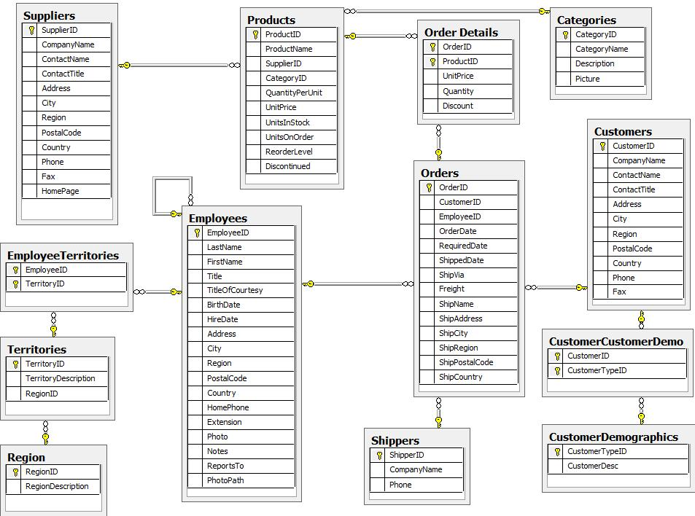

First, this is a rather large and detailed model. We can scale this down a bit for our example and choose the entities that are most critical for our graph - in other words, those that might benefit most from seeing the connections. For our use case, we really want to optimize the relationships with orders - what products were involved (with the categories and suppliers for those products), which employees worked on them and those employees' managers.

Using these business requirements, we can narrow our model down to these essential entities.

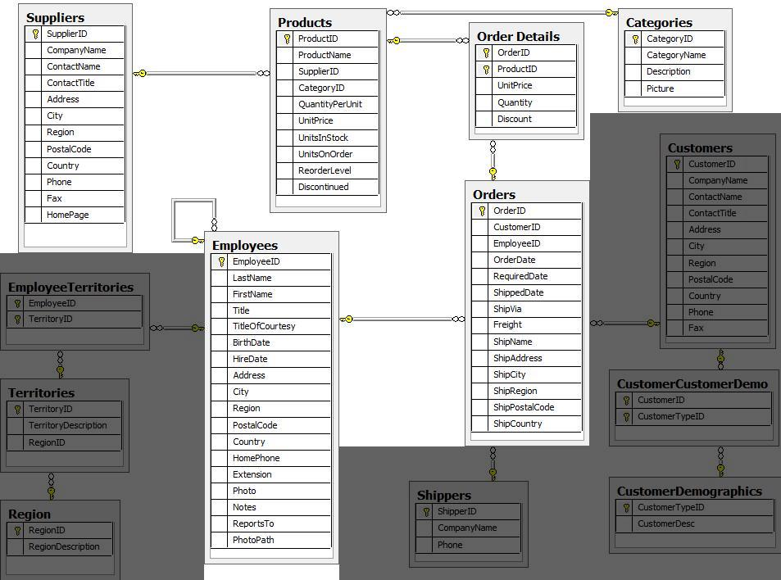

## Developing a Graph Model

The first thing you will need to do to get data from a relational database into a graph is to translate the relational data model to a graph data model. Determining how you want to structure tables and rows as nodes and relationships may vary depending on what is most important to your business needs.

|  |
| --- |
| For more information on adapting your graph model to different scenarios, check out our [**modeling designs**](https://neo4j.com/developer/modeling-designs/) guide. |

When deriving a graph model from a relational model, you should keep a couple of general guidelines in mind.

1. A row is a node.
2. A table name is a label name.
3. A join or foreign key is a relationship.

With these principles in mind, we can map our relational model to a graph with the following steps:

### Rows to Nodes, Table names to labels

1. Each row on our Orders table becomes a node in our graph with Order as the label.
2. Each row on our Products table becomes a node with Product as the label.
3. Each row on our Suppliers table becomes a node with Supplier as the label.
4. Each row on our Categories table becomes a node with Category as the label.
5. Each row on our Employees table becomes a node with Employee as the label.

### Joins to relationships

1. Join between Suppliers and Products becomes a relationship named SUPPLIES (where supplier supplies product).
2. Join between Products and Categories becomes a relationship named PART_OF (where product is part of a category).
3. Join between Employees and Orders becomes a relationship named SOLD (where employee sold an order).
4. Join between Employees and itself (unary relationship) becomes a relationship named REPORTS_TO (where employees have a manager).
5. Join with join table (Order Details) between Orders and Products becomes a relationship named CONTAINS with properties of unitPrice, quantity, and discount (where order contains a product).

If we draw our translation out on the whiteboard, we have this graph data model.

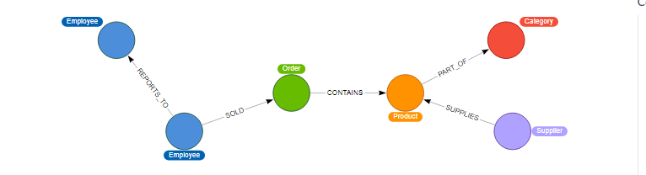

Now, we can, of course, decide that we want to include the rest of the entities from our relational model, but for now, we will keep to this smaller graph model.

### How does the Graph Model Differ from the Relational Model?

* There are no nulls. Non-existing value entries (properties) are just not present.
* It describes the relationships in more detail. For example, we know that an employee SOLD an order rather than having a foreign key relationship between the Orders and Employees tables. We could also choose to add more metadata about that relationship, should we wish.
* Either model can be more normalized. For example, addresses have been denormalized in several of the tables, but could have been in a separate table. In a future version of our graph model, we might also choose to separate addresses from the Order (or Supplier or Employee) entities and create separate Address nodes.

## Exporting Relational Tables to CSV

Thankfully, this step has already been done for you with the Northwind data you will use later on in this Guide.

However, if you are working with another data domain, you will need to take the data from the relational tables and put it in another format for loading to the graph. A common format that many systems can handle a flat file of comma-separated values (CSV).

Here is an example script we already ran to export the northwind data into CSV files for you.

***export_csv.sql***

COPY (SELECT * FROM customers) TO '/tmp/customers.csv' WITH CSV header;

COPY (SELECT * FROM suppliers) TO '/tmp/suppliers.csv' WITH CSV header;

COPY (SELECT * FROM products) TO '/tmp/products.csv' WITH CSV header;

COPY (SELECT * FROM employees) TO '/tmp/employees.csv' WITH CSV header;

COPY (SELECT * FROM categories) TO '/tmp/categories.csv' WITH CSV header;

COPY (SELECT * FROM orders

LEFT OUTER JOIN order_details ON order_details.OrderID = orders.OrderID) TO '/tmp/orders.csv' WITH CSV header;

If you want to create the CSV files yourself using your own northwind RDBMS, you can run this script against your RDBMS with the command psql -d northwind < export_csv.sql.

**Note**: You need not run this script unless you want to execute it against your own northwind RDBMS.

## Importing the Data using Cypher

You will use Cypher’s [**LOAD CSV**](https://neo4j.com/docs/cypher-manual/current/clauses/load-csv/) command to transform the contents of the CSV file into a graph structure.

When you use LOAD CSV to create nodes and relationships in the database, you have two options for where the CSV files reside:

* In the **import** folder for the Neo4j instance that you can manage.
* From a publicly-available location such as an S3 bucket or a github location. You must use this option if you are using Neo4j AuraDB or Neo4j Sandbox.

If you want to use the CSV files for your Neo4j instance that you manage, you can copy the CSV files from [**northwind zip from github**](https://github.com/neo4j-contrib/developer-resources/tree/gh-pages/data/northwind/northwind.zip) and place them in the **import** folder for your Neo4j DBMS.

We have already placed these CSV files in Gihub for your access to them.

You use use Cypher’s LOAD CSV statement to read each file and add Cypher clauses after it to take the row/column data and transform it to the graph.

Next you will execute Cypher code to:

1. Load the nodes from the CSV files.
2. Create the indexes and constraint for the data in the graph.
3. Create the relationships between the nodes.

### Creating Order nodes

Execute this Cypher block to create the Order nodes in the database:

*// Create orders*

LOAD CSV WITH HEADERS FROM 'https://gist.githubusercontent.com/jexp/054bc6baf36604061bf407aa8cd08608/raw/8bdd36dfc88381995e6823ff3f419b5a0cb8ac4f/orders.csv' AS row

MERGE (order:Order {orderID: row.OrderID})

ON CREATE SET order.shipName = row.ShipName;

If you have placed the CSV files in to the **import** folder, you should use this code syntax to load the CSV files from a local directory:

// Create orders

LOAD CSV WITH HEADERS FROM 'file:///orders.csv' AS row

MERGE (order:Order {orderID: row.OrderID})

ON CREATE SET order.shipName = row.ShipName;

This code creates 830 Order nodes in the database.

You can view some of the nodes in the database by executing this code:

MATCH (o:Order) return o LIMIT 5;

The graph view is:

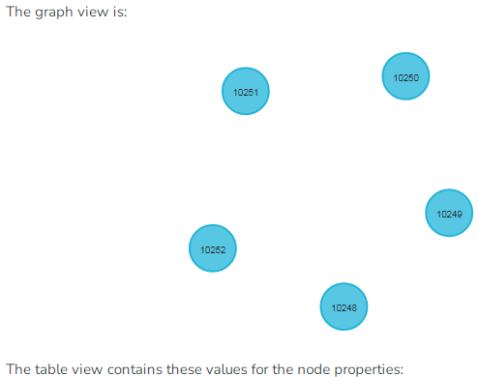

The table view contains these values for the node properties:

| **o** |
| --- |
| {"shipName":Vins et alcools Chevalier,"orderID":10248} |
| {"shipName":Toms Spezialitäten,"orderID":10249} |
| {"shipName":Hanari Carnes,"orderID":10250} |
| {"shipName":Victuailles en stock,"orderID":10251} |
| {"shipName":Suprêmes délices,"orderID":10252} |

You might notice that you have not imported all of the field columns in the CSV file. With your statements, you can choose which properties are needed on a node, which can be left out, and which might need imported to another node type or relationship. You might also notice that you used the [**MERGE keyword**](https://neo4j.com/docs/cypher-manual/current/clauses/merge/), instead of [**CREATE**](https://neo4j.com/docs/cypher-manual/current/clauses/create/). Though we feel pretty confident there are no duplicates in our CSV files, we can use MERGE as good practice for ensuring unique entities in our database.

### Creating Product nodes

Execute this code to create the Product nodes in the database:

*// Create products*

LOAD CSV WITH HEADERS FROM 'https://gist.githubusercontent.com/jexp/054bc6baf36604061bf407aa8cd08608/raw/8bdd36dfc88381995e6823ff3f419b5a0cb8ac4f/products.csv' AS row

MERGE (product:Product {productID: row.ProductID})

ON CREATE SET product.productName = row.ProductName, product.unitPrice = toFloat(row.UnitPrice);

This code creates 77 Product nodes in the database.

You can view some of these nodes in the database by executing this code:

MATCH (p:Product) return p LIMIT 5;

The graph view is:

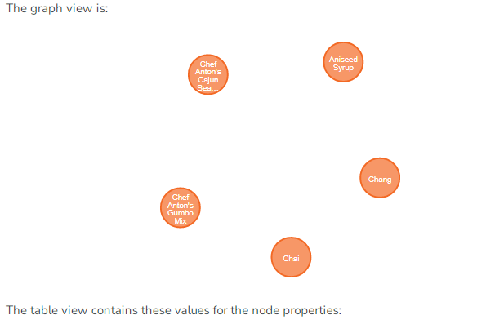

The table view contains these values for the node properties:

| **p** |
| --- |
| {"unitPrice":18.0,"productID":1,"productName":Chai} |
| {"unitPrice":19.0,"productID":2,"productName":Chang} |
| {"unitPrice":10.0,"productID":3,"productName":Aniseed Syrup} |
| {"unitPrice":22.0,"productID":4,"productName":Chef Anton’s Cajun Seasoning} |
| {"unitPrice":21.35,"productID":5,"productName":Chef Anton’s Gumbo Mix} |

### Creating Supplier nodes

Execute this code to create the Supplier nodes in the database:

*// Create suppliers*

LOAD CSV WITH HEADERS FROM 'https://gist.githubusercontent.com/jexp/054bc6baf36604061bf407aa8cd08608/raw/8bdd36dfc88381995e6823ff3f419b5a0cb8ac4f/suppliers.csv' AS row

MERGE (supplier:Supplier {supplierID: row.SupplierID})

ON CREATE SET supplier.companyName = row.CompanyName;

This code creates 29 Supplier nodes in the database.

You can view some of these nodes in the database by executing this code:

MATCH (s:Supplier) return s LIMIT 5;

The graph view is:

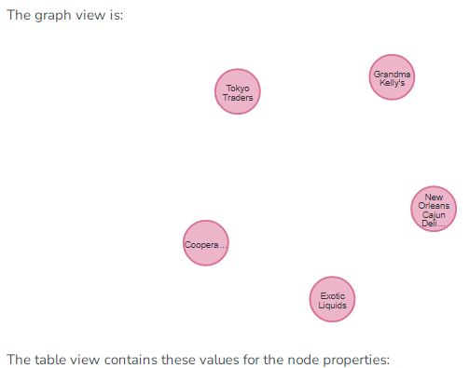

The table view contains these values for the node properties:

| **s** |
| --- |
| {"supplierID":1,"companyName":Exotic Liquids} |
| {"supplierID":2,"companyName":New Orleans Cajun Delights} |
| {"supplierID":3,"companyName":Grandma Kelly’s Homestead} |
| {"supplierID":4,"companyName":Tokyo Traders} |
| {"supplierID":5,"companyName":Cooperativa de Quesos 'Las Cabras'} |

### Creating Employee nodes

Execute this code to create the Supplier nodes in the database:

*// Create employees*

LOAD CSV WITH HEADERS FROM 'https://gist.githubusercontent.com/jexp/054bc6baf36604061bf407aa8cd08608/raw/8bdd36dfc88381995e6823ff3f419b5a0cb8ac4f/employees.csv' AS row

MERGE (e:Employee {employeeID:row.EmployeeID})

ON CREATE SET e.firstName = row.FirstName, e.lastName = row.LastName, e.title = row.Title;

This code creates 9 Employee nodes in the database.

You can view some of these nodes in the database by executing this code:

MATCH (e:Employee) return e LIMIT 5;

The graph view is:

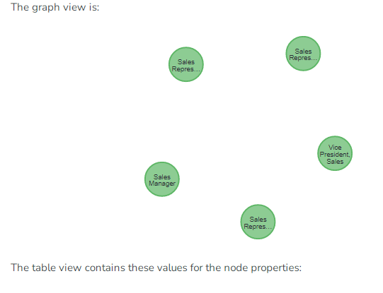

The table view contains these values for the node properties:

| **e** |
| --- |
| {"lastName":Davolio,"firstName":Nancy,"employeeID":1,"title":Sales Representative} |
| {"lastName":Fuller,"firstName":Andrew,"employeeID":2,"title":Vice President, Sales} |
| {"lastName":Leverling,"firstName":Janet,"employeeID":3,"title":Sales Representative} |
| {"lastName":Peacock,"firstName":Margaret,"employeeID":4,"title":Sales Representative} |
| {"lastName":Buchanan,"firstName":Steven,"employeeID":5,"title":Sales Manager} |

### Creating Category nodes

*// Create categories*

LOAD CSV WITH HEADERS FROM 'https://gist.githubusercontent.com/jexp/054bc6baf36604061bf407aa8cd08608/raw/8bdd36dfc88381995e6823ff3f419b5a0cb8ac4f/categories.csv' AS row

MERGE (c:Category {categoryID: row.CategoryID})

ON CREATE SET c.categoryName = row.CategoryName, c.description = row.Description;

This code creates 8 Category nodes in the database.

You can view some of these nodes in the database by executing this code:

MATCH (c:Category) return c LIMIT 5;

The graph view is:

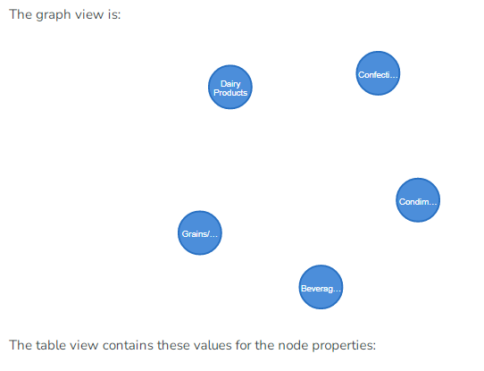

The table view contains these values for the node properties:

| **c** |
| --- |
| {"description":Soft drinks, coffees, teas, beers, and ales,"categoryName":Beverages,"categoryID":1} |
| {"description":Sweet and savory sauces, relishes, spreads, and seasonings,"categoryName":Condiments,"categoryID":2} |
| {"description":Desserts, candies, and sweet breads,"categoryName":Confections,"categoryID":3} |
| {"description":Cheeses,"categoryName":Dairy Products,"categoryID":4} |
| {"description":Breads, crackers, pasta, and cereal,"categoryName":Grains/Cereals,"categoryID":5} |

|  |
| --- |
| For very large commercial or enterprise datasets, you may find out-of-memory errors, especially on smaller machines. To avoid these situations, you can prefix the statement with the :auto USING PERIODIC COMMIT query hint to commit data in batches. This practice is not standard recommendation for smaller datasets, but is only recommended when memory issues are threatened. More information on this query hint can be found in the [**manual**](https://neo4j.com/docs/cypher-manual/current/query-tuning/using/#query-using-periodic-commit-hint). |

## Creating the indexes and constraints for the data in the graph

After the nodes are created, you need to create the relationships between them. Importing the relationships will mean looking up the nodes you just created and adding a relationship between those existing entities. To ensure the lookup of nodes is optimized, you will create indexes for any node properties used in the lookups (often the id or another unique value).

We also want to create a constraint (also creates an index with it) that will disallow orders with the same id from getting created, preventing duplicates. Finally, as the indexes are created after the nodes are inserted, their population happens asynchronously, so we call db.awaitIndexes() to block until they are populated.

Execute this code block:

CREATE INDEX product_id FOR (p:Product) ON (p.productID);

CREATE INDEX product_name FOR (p:Product) ON (p.productName);

CREATE INDEX supplier_id FOR (s:Supplier) ON (s.supplierID);

CREATE INDEX employee_id FOR (e:Employee) ON (e.employeeID);

CREATE INDEX category_id FOR (c:Category) ON (c.categoryID);

CREATE CONSTRAINT order_id ON (o:Order) ASSERT o.orderID IS UNIQUE;

CALL db.awaitIndexes();

After you execute this code, you can execute this code to view the indexes (and constraint) in the database:

CALL db.indexes();

You should see these indexes (and constraint) in the database:

| **id** | **name** | **state** | **populationPercent** | **uniqueness** | **type** | **entityType** | **labelsOrTypes** | **properties** | **provider** |
| --- | --- | --- | --- | --- | --- | --- | --- | --- | --- |
| 5 | category_id | ONLINE | 100.0 | NONUNIQUE | BTREE | NODE | [Category] | [categoryID] | native-btree-1.0 |
| 4 | employee_id | ONLINE | 100.0 | NONUNIQUE | BTREE | NODE | [Employee] | [employeeID] | native-btree-1.0 |
| 6 | order_id | ONLINE | 100.0 | UNIQUE | BTREE | NODE | [Order] | [orderID] | native-btree-1.0 |
| 1 | product_id | ONLINE | 100.0 | NONUNIQUE | BTREE | NODE | [Product] | [productID] | native-btree-1.0 |
| 2 | product_name | ONLINE | 100.0 | NONUNIQUE | BTREE | NODE | [Product] | [productName] | native-btree-1.0 |
| 3 | supplier_id | ONLINE | 100.0 | NONUNIQUE | BTREE | NODE | [Supplier] | [supplierID] | native-btree-1.0 |

## Creating the relationships between the nodes

Next you will create relationships:

1. Between orders and employees.
2. Between products and suppliers and between products and categories.
3. Between employees.

### Creating relationships between orders and employees

With the initial nodes and indexes in place, you can now create the relationships for orders to products and orders to employees.

Execute this code block:

*// Create relationships between orders and products*

LOAD CSV WITH HEADERS FROM 'https://gist.githubusercontent.com/jexp/054bc6baf36604061bf407aa8cd08608/raw/8bdd36dfc88381995e6823ff3f419b5a0cb8ac4f/orders.csv' AS row

MATCH (order:Order {orderID: row.OrderID})

MATCH (product:Product {productID: row.ProductID})

MERGE (order)-[op:CONTAINS]->(product)

ON CREATE SET op.unitPrice = toFloat(row.UnitPrice), op.quantity = toFloat(row.Quantity);

This code creates 2155 relationships in the graph.

You can view some of them by executing this code:

MATCH (o:Order)-[]-(p:Product)

RETURN o,p LIMIT 10;

Your graph view should look something like this:

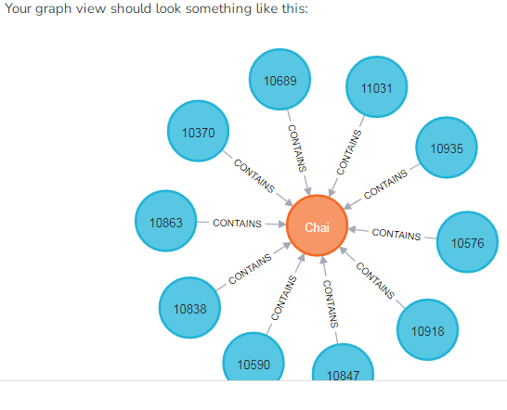

Then, execute this code block:

*// Create relationships between orders and employees*

LOAD CSV WITH HEADERS FROM 'https://gist.githubusercontent.com/jexp/054bc6baf36604061bf407aa8cd08608/raw/8bdd36dfc88381995e6823ff3f419b5a0cb8ac4f/orders.csv' AS row

MATCH (order:Order {orderID: row.OrderID})

MATCH (employee:Employee {employeeID: row.EmployeeID})

MERGE (employee)-[:SOLD]->(order);

This code creates 830 relationships in the graph.

You can view some of them by executing this code:

MATCH (o:Order)-[]-(e:Employee)

RETURN o,e LIMIT 10;

Your graph view should look something like this:

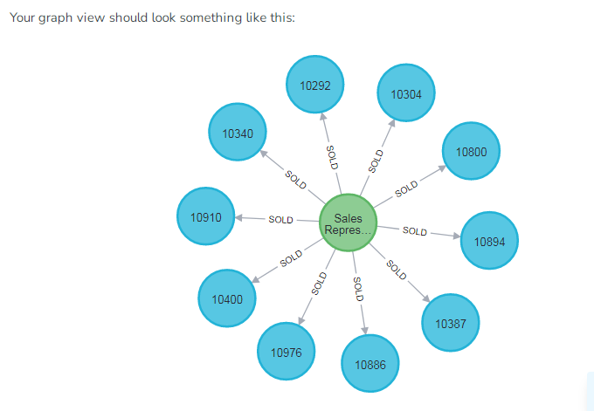

### Creating relationships between products and suppliers and between products and categories

Next, create relationships between products, suppliers, and categories:

Execute this code block:

*// Create relationships between products and suppliers*

LOAD CSV WITH HEADERS FROM 'https://gist.githubusercontent.com/jexp/054bc6baf36604061bf407aa8cd08608/raw/8bdd36dfc88381995e6823ff3f419b5a0cb8ac4f/products.csv

' AS row

MATCH (product:Product {productID: row.ProductID})

MATCH (supplier:Supplier {supplierID: row.SupplierID})

MERGE (supplier)-[:SUPPLIES]->(product);

This code creates 77 relationships in the graph.

You can view some of them by executing this code:

MATCH (s:Supplier)-[]-(p:Product)

RETURN s,p LIMIT 10;

Your graph view should look something like this:

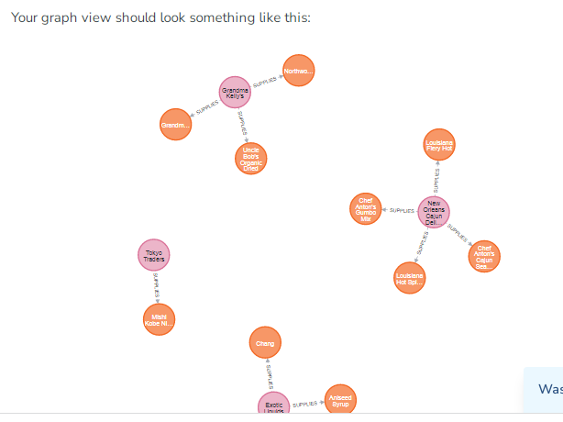

Then, execute this code block:

*// Create relationships between products and categories*

LOAD CSV WITH HEADERS FROM 'https://gist.githubusercontent.com/jexp/054bc6baf36604061bf407aa8cd08608/raw/8bdd36dfc88381995e6823ff3f419b5a0cb8ac4f/products.csv

' AS row

MATCH (product:Product {productID: row.ProductID})

MATCH (category:Category {categoryID: row.CategoryID})

MERGE (product)-[:PART_OF]->(category);

This code creates 77 relationships in the graph.

You can view some of them by executing this code:

MATCH (c:Category)-[]-(p:Product)

RETURN c,p LIMIT 10;

Your graph view should look something like this:

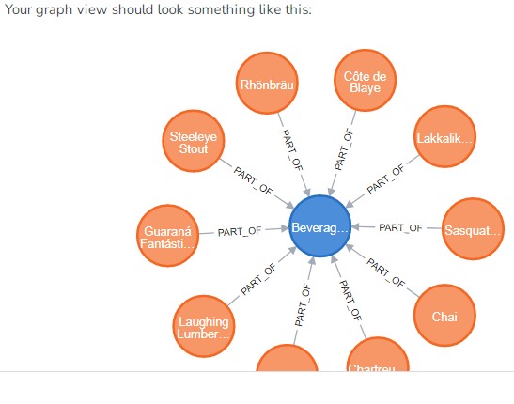

### Creating relationships between employees

Lastly, you will create the 'REPORTS_TO' relationship between employees to represent the reporting structure:

Execute this code block:

*// Create relationships between employees (reporting hierarchy)*

LOAD CSV WITH HEADERS FROM 'https://gist.githubusercontent.com/jexp/054bc6baf36604061bf407aa8cd08608/raw/8bdd36dfc88381995e6823ff3f419b5a0cb8ac4f/employees.csv' AS row

MATCH (employee:Employee {employeeID: row.EmployeeID})

MATCH (manager:Employee {employeeID: row.ReportsTo})

MERGE (employee)-[:REPORTS_TO]->(manager);

This code creates 8 relationships in the graph.

You can view some of them by executing this code:

MATCH (e1:Employee)-[]-(e2:Employee)

RETURN e1,e2 LIMIT 10;

Your graph view should look something like this:

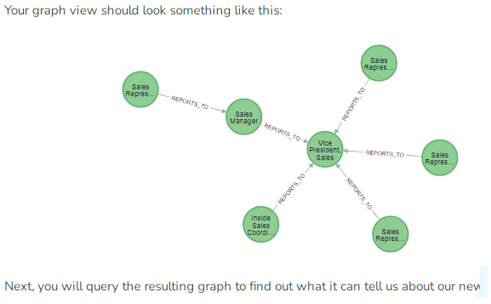

Next, you will query the resulting graph to find out what it can tell us about our newly-imported data.

## Querying the Graph

We might start with a couple of general queries to verify that our data matches the model we designed earlier in the guide. Here are some example queries.

Execute this code block:

*//find a sample of employees who sold orders with their ordered products*

MATCH (e:Employee)-[rel:SOLD]->(o:Order)-[rel2:CONTAINS]->(p:Product)

RETURN e, rel, o, rel2, p LIMIT 25;

Execute this code block:

*//find the supplier and category for a specific product*

MATCH (s:Supplier)-[r1:SUPPLIES]->(p:Product {productName: 'Chocolade'})-[r2:PART_OF]->(c:Category)

RETURN s, r1, p, r2, c;

Once you are comfortable that the data aligns with our data model and everything looks correct, you can start querying to gather information and insight for business decisions.

### Which Employee had the Highest Cross-Selling Count of 'Chocolade' and Another Product?

Execute this code block:

MATCH (choc:Product {productName:'Chocolade'})<-[:CONTAINS]-(:Order)<-[:SOLD]-(employee),

(employee)-[:SOLD]->(o2)-[:CONTAINS]->(other:Product)

RETURN employee.employeeID as employee, other.productName as otherProduct, count(distinct o2) as count

ORDER BY count DESC

LIMIT 5;

Looks like employee No. 4 was busy, though employee No. 1 also did well! Your results should look something like this:

| **employee** | **otherProduct** | **count** |
| --- | --- | --- |
| 4 | Gnocchi di nonna Alice | 14 |
| 4 | Pâté chinois | 12 |
| 1 | Flotemysost | 12 |
| 3 | Gumbär Gummibärchen | 12 |
| 1 | Pavlova | 11 |

### How are Employees Organized? Who Reports to Whom?

Execute this code block:

MATCH (e:Employee)<-[:REPORTS_TO]-(sub)

RETURN e.employeeID AS manager, sub.employeeID AS employee;

Your results should look something like this:

| **manager** | **employee** |
| --- | --- |
| 2 | 3 |
| 2 | 4 |
| 2 | 5 |
| 2 | 1 |
| 2 | 8 |
| 5 | 9 |
| 5 | 7 |
| 5 | 6 |

Notice that employee No. 5 has people reporting to them but also reports to employee No. 2.

Next, let’s investigate that a bit more.

### Which Employees Report to Each Other Indirectly?

Execute this code block:

MATCH path = (e:Employee)<-[:REPORTS_TO*]-(sub)

WITH e, sub, [person in NODES(path) | person.employeeID][1..-1] AS path

RETURN e.employeeID AS manager, path as middleManager, sub.employeeID AS employee

ORDER BY size(path);

Your results should look something like this:

| **manager** | **middleManager** | **employee** |
| --- | --- | --- |
| 2 | [] | 3 |
| 2 | [] | 4 |
| 2 | [] | 5 |
| 2 | [] | 1 |
| 2 | [] | 8 |
| 5 | [] | 9 |
| 5 | [] | 7 |
| 5 | [] | 6 |
| 2 | [5] | 9 |
| 2 | [5] | 7 |
| 2 | [5] | 6 |

### How Many Orders were Made by Each Part of the Hierarchy?

Execute this code block:

MATCH (e:Employee)

OPTIONAL MATCH (e)<-[:REPORTS_TO*0..]-(sub)-[:SOLD]->(order)

RETURN e.employeeID as employee, [x IN COLLECT(DISTINCT sub.employeeID) WHERE x <> e.employeeID] AS reportsTo, COUNT(distinct order) AS totalOrders

ORDER BY totalOrders DESC;

Your results should look something like this:

| **employee** | **reportsTo** | **totalOrders** |
| --- | --- | --- |
| 2 | [8,1,5,6,7,9,4,3] | 830 |
| 5 | [6,7,9] | 224 |
| 4 | [] | 156 |
| 3 | [] | 127 |
| 1 | [] | 123 |
| 8 | [] | 104 |
| 7 | [] | 72 |
| 6 | [] | 67 |
| 9 | [] | 43 |

## What’s Next?

If you followed along with each step through this guide, then you might want to explore the data set with more queries and try to answer additional questions you came up with for the data. You may also want to apply these same principles to your own or another data set for analysis.

If you used this as a process flow to apply to a different data set or you would like to do that next, feel free to start at the top and work through this guide again with another domain. The steps and processes still apply (though, of course, the data model, queries, and business questions will need adjusted).

If you have data that needs additional cleansing and manipulation than what is covered in this guide, the [**APOC library**](https://neo4j.com/labs/apoc/) may be able to help. It contains hundreds of procedures and functions for handling large amounts of data, translating values, cleaning messy data sources, and more!

If you are interested in doing a one-time initial dump of relational data to Neo4j, then the [**Neo4j ETL Tool**](https://neo4j.com/labs/etl-tool/) might be what you are looking for. The application is designed with a point-and-click user interface with the goal of fast, simple relational-to-graph loads that help new and existing users gain faster value from seeing their data as a graph without Cypher, import procedures, or other code.